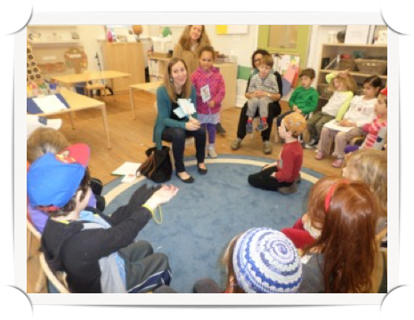
RESEARCH THROUGH INTERVIEWING

One of the skills the children was introduced to during our Library Project is interviewing. We started by learning the skills of about how to interview people from a local journalist, Michelle Davis. Michelle shared that she is a writer for different newspapers, magazines and publications. She talked about the type of tools she uses and then gave the children interviewing tips and suggestions including: collect information ahead of time in order to ask good questions, save the hard questions for the end of the interview, and be sure to listen carefully. Then, the children used these interviewing skills as the base of their research. Each child in Kindergarten was a part of an interviewing committee. The committees (South Campus, North Campus, Local Libraries) interviewed community members in order to find out more about how they use libraries and their needs for one. The students also interviewed a past Liberian and our director, Melissa Davis to focus on the physical space of our school’s library to help create ideas for the organization of our library.

The children interviewed an array of community members from our school and our DC area. Here is what the children in each committee learned:

NORTH CAMPUS COMMITTEE
The children in the North Campus Committee shared their interview thoughts at our Kindergarten Town Hall meeting. Gabi shared that we interviewed Ms. Collier, our North campus librarian. She shared the Ms. Collier is the only person who helps organize at the library and how Ms. Collier might need help from the Kindergarteners. David shared that the books are organized alphabetically in the different sections: picture books, fiction, and non-fiction. Zecharyah shared that every book in the North campus library has 4 labels so we know where to put the books away (including the stamps with our school address). Lucy shared that when we came back to south campus we started to brainstorm the different categories of books we might have our new library. She presented the idea of having a “Dr. Seuss” section.

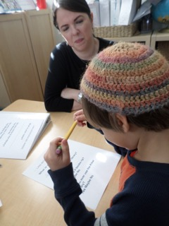
SOUTH CAMPUS COMMITTEE
Noah interviewed our Pre-K friend, Amelia to ask about what ways pre-k uses the Kikar library. Amelia shared that because some pre-k friends do not know how to read, they should paint (or color) stickers in the books so people who don’t know how to read can know where to put books away!

Ms. Marks (from the admission’s office) shared that she wants to see work from the children inside of the Kikar library because that is a great place to document our learning.

During our interview with Ms. Graham, she shared that there are two main reasons she uses the Kikar library: to put away birthday books and to help pick out books for children who are spending time on the lobby couches. We thought about an idea to create small library by Ms. Graham’s desk and to design a better system to put Birthday Book away.

LOCAL COMMITTEE
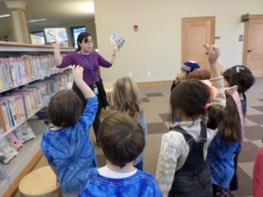
The children traveled around the Mount Pleasant library in order to learn about the organization systems and comfy areas in this public library. Ms. Shoshana, the Liberian taught us a that their books are categorized by reading level, fiction, chapter books, picture books, other languages, and seasonal books. We observed how books are displayed on shelves. Sometimes the books are facing out and sometimes their spine is out. The children thought about the different ways to display books in our Kikar library on South Campus. We also noticed that there were big areas in which children can sit, read, and have story times. We tried to think about different items we could have in a cozy area and Ms. Shoshana gave us a great idea about having big cuddly stuffed animals to sit on and read to. Throughout the tour, the children thought about the different ways to organize our books and really caught on to the idea about why in the fiction area the books are listed by author and in the non-fiction area they are listed by subject.

Mrs. Terry Blackwelder, a former librarian for Lowell School (when they were housed on our South Campus), came to speak to all of Kindergarten about the history of the library when it was Lowell. Mrs. Blackwelder emphasized that every school that has been in the South Campus location has made changes to the building so that it works best for them.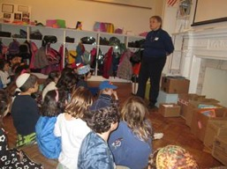

The Kindergarten classes to come together to lean about the history of our community. Mrs. Davis showed us pictures of her visit with G’vert Reem to South Campus when it use to be Lowell School.
