**Buy an amazing**

**Pumpkin Chocolate Chip Muffin**

Cost: $1.00

Where: outside the cafeteria after davening

When: Tuesday, November 22nd

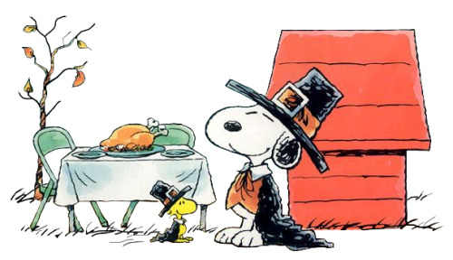

Skip the Turkey, Snoopy, and buy a **pumpkin chocolate chip** **muffin** from the talented

T.A.M. Team

Happy

Thanksgiving!