**Prototyping the South Campus Library Island**

**The Prototype must be:**

* **Able to hold books**
* **Able to move**
* **Small enough for kids**
* 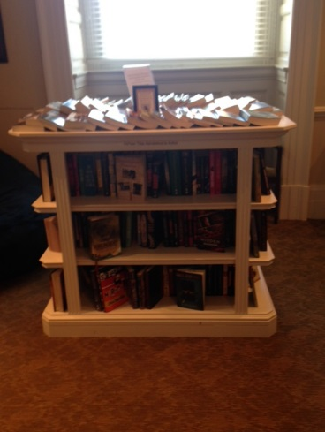**Able to display things**

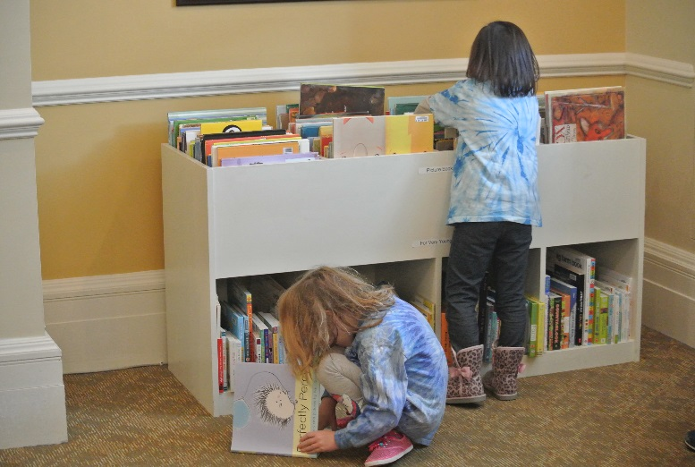

**These are islands that we encountered on a fieldtrip to the Library of Congress. Since our encounter, we have been using them as inspiration for our work. As we create our prototypes, we keep our needs in mind by referring to our “must be” list that the children made based on the needs of our community on South Campus.**