Name Date
Mrs. Daniel Biology I Honors
Quiz: Pig Heart Dissection

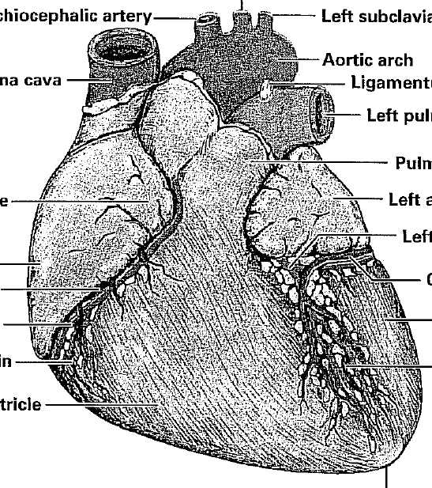
Part I: Identify the parts of the heart indicated
Part II: Describe the function of the following parts of the heart
1) Aorta
2) Pulmonary veins
3) right ventricle

