The Kohelet Prize for Interdisciplinary Integration
Awarded for excellence in integrating multiple disciplines in a single multi-week unit. Preference will be given to units which incorporate Judaic Studies and General Studies and involve multiple faculty members.
“Unity in the School Community”
The Problem
Jewish Day Schools more often than not, draw an obvious seam between Judaic and General studies. It is almost as if we have brought a public school into our Jewish schools and created a separation between “Church and State.” There becomes a tug-of-war: If General studies teachers are superior to Judaic faculty or the curriculum is presented with more bells and whistles, students have greater appreciation and awe for secular education, and possibly diminishing the ‘value’ of the Judaics in student’s eyes.
We are cheating our students, in the sense that students may be attending a Jewish Day School, but then “take off” their kippah as soon as they leave school. Judaism is not being integrated into their lives.
Our Solution
At the Jewish Academy, integration of Judaics and General Studies is fundamental. We have developed a curriculum map of five integrated units (each between 6- 8 weeks long) with our teaching team composed of our Judaics, math, ELA and science teachers. Each unit is driven by an ‘Essential Question’.
An example: the unit connected to Chanukah this year is “What Does ‘Light Over Darkness’ Look Like?” Once students know the details of Chanukah, they are ready to dig deeper. ‘Hope’ is an underlying theme selected for this year’s focus. Students, divided into three bands of grade levels (K-2, 3-5, and 6-8) all run with the same Essential Question. The results:
- Our K-2 students are creating a ‘How To’ book to facilitate bringing the joy of Chanukah to others. Hebrew language, Jewish law, history, math, writing, art - all being utilized to create a comprehensive understanding at a basic level of this holiday. (In math, our children are learning to calculate and graph how many candles they would have to purchase if they are increasing the number of candles daily all the way to eight candles. Creating a Chanukah cookbook would involve interviews, math, art, research on different oils, community traditions, etc.)
- Our 3-5 grade students are ‘planning a Chanukah event’, in line with spreading the light of Chanukah. All aspects of running a Chanukah program will be covered: writing a press release, creating a program, selecting entertainment, deciding upon refreshments. How much food would one need to purchase? What is the budget for such an undertaking? Should there be an admission charge? In order for our students to plan this event, they will incorporate math, graphic design skills in the making of flyers, persuasive writing, and artistic talents. Their collaboration skills will be honed. They will own the program!
- Our 6-8 Graders are designing a robotic arm (https://www.amazon.com/OWI-OWI-535-Robotic-Arm-Edge/dp/B0017OFRCY) in response to the Essential Question of how Chanukah brings hope to society (Light Over Darkness). A STEM unit about robots in general and developing a prosthesis to help disabled people is a perfect synthesis.

A Curriculum Celebration is held upon the completion of each unit. Our parents are in awe as their children become their teachers for the day. Students share their knowledge and experiments/projects with their parents. This is akin to a Science Fair in terms of presentation, but the scope and creativity is greater because it integrates all the learning modalities.
Impact on our Students
Students are empowered to explore, research and present their ideas according to their understanding. Our students have buy-in to what they are learning. There is an old joke asking what is the difference between ignorance and apathy, with the answer being, “I don’t know, and I don’t care.”
Our students both know and care. This is what integrated education should produce.
I am including pictures of our previous Curriculum Celebration so that this committee can see some of our student work. I’m also including an essay from one of our Middle Schoolers on Parshat Noach which he wrote prior to the election, but was read to our entire parent body at our first Curriculum Celebration following the election. The eternal message of the Torah which he conveyed in that piece was a gift to all present.
Conclusion
“We cannot solve our problems with the same thinking we used when we created them.” Albert Einstein
We must find and employ ways and methods to keep our students engaged, not merely to maintain the status quo, but to shake up and invigorate Jewish education. Same old, same old is not working. Our students deserve more. Our future deserves more.
The Jewish Academy is changing the mold.

With Blessings,
Chaya Teldon Head of School

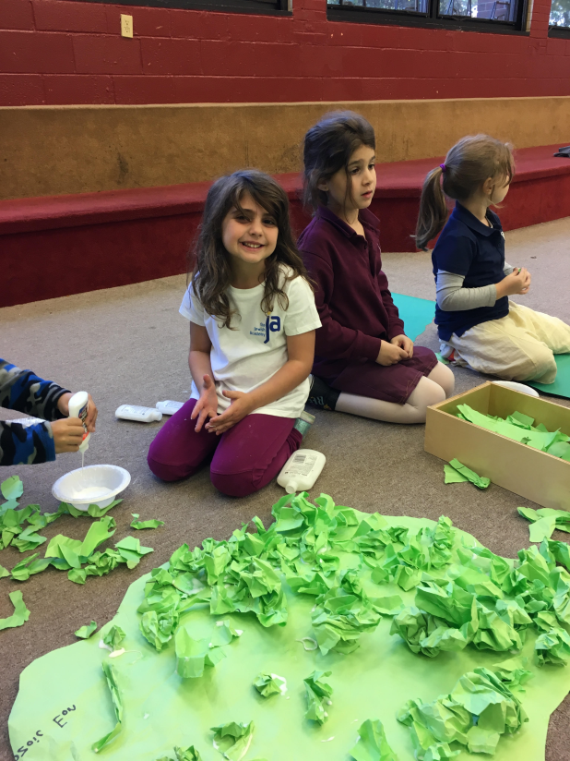
All hands on deck to prepare for our Curriculum Celebration.

Dioramas come alive as students confidently explain their projects and share their research.
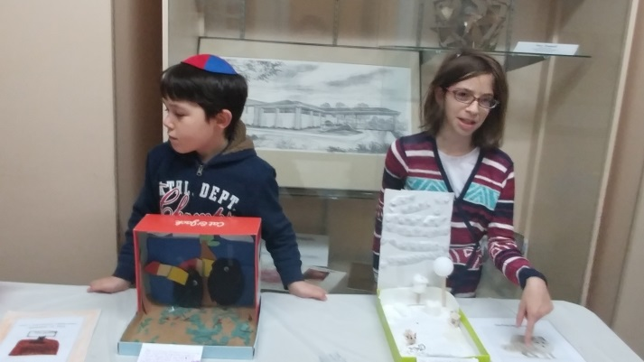
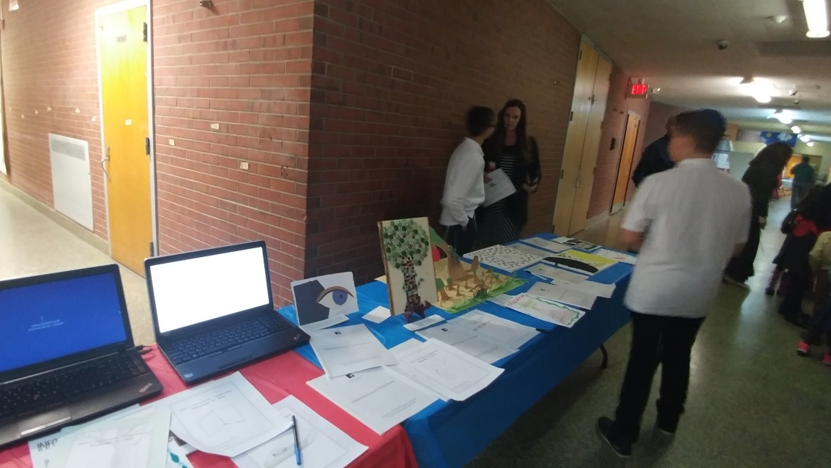

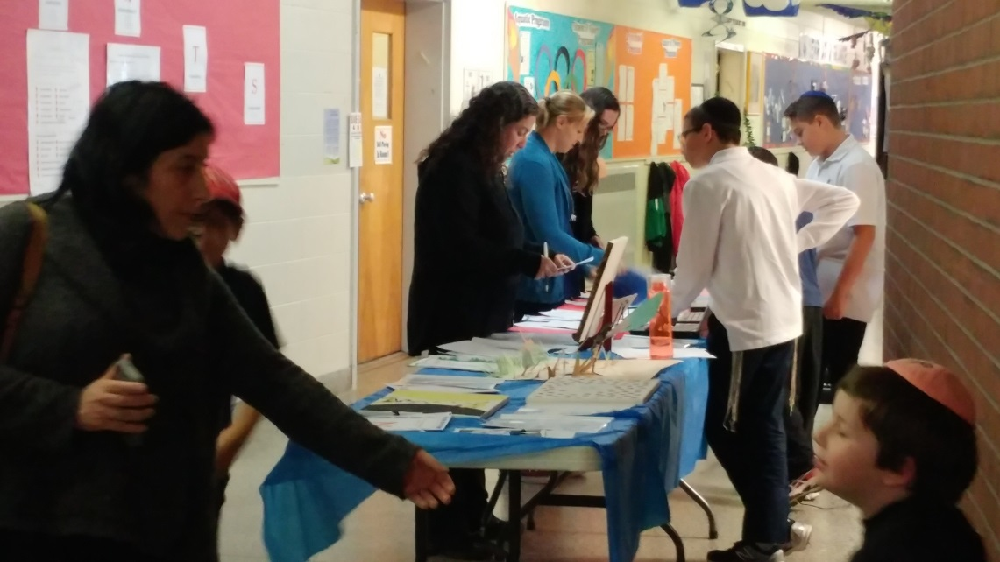
Varied means of research are welcomed, as student interests and talents are diverse.

Student engagement is palpable. Parents are impressed.
The bar is raised for all.

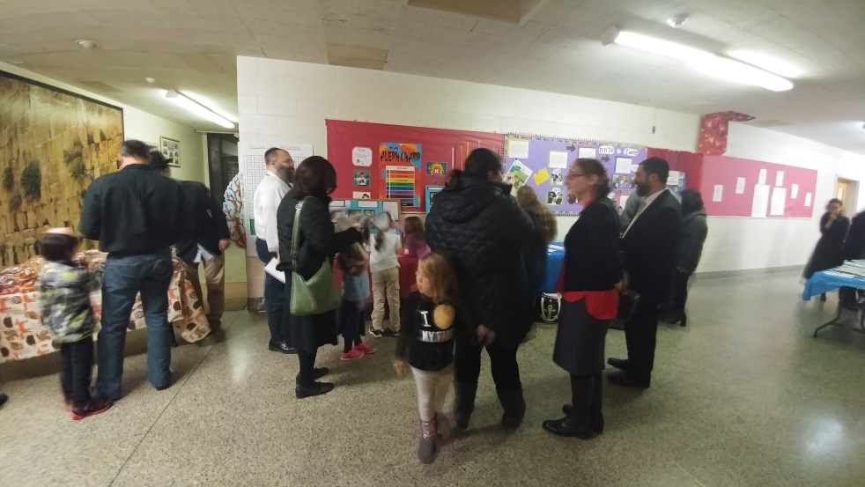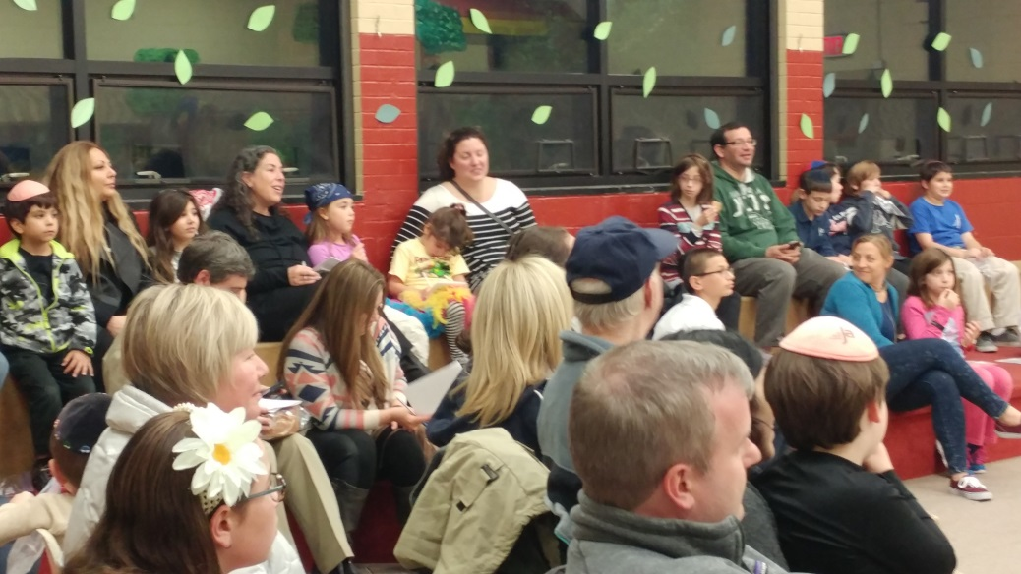
We had 95% parent attendance

Visit the Rainforest!!
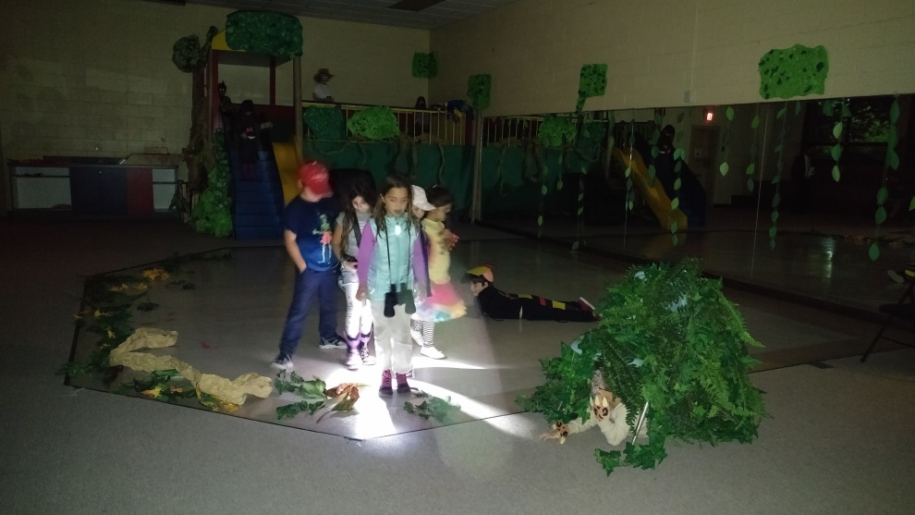
Parshat Noach Aden Bentov

Parshat Noach is the 2nd Parsha in the Torah, naming Noah's 70 grandchildren/great-grandchildren, and the great flood. Parshat Noach is an interesting and long Parsha while having a valuable lesson behold inside. What does this Parsha mean to me?

Noach was out on a ship in the middle of the flooded earth for nearly one year, keeping calm and righteous with a belief of coming home. He sent out a dove, hoping it would not come back, which would alert them the dove landed and the flood is over. The dove came back, but with a ‘sign’, an olive branch, telling them that the flood will calm down, but not yet. Noach did not show anger and disappointment like people do today, he did not put anger towards the dove or express himself in a not friendly manner. He simply put the dove back with the others and took the branch with the satisfaction he will return but not today. This is a valuable lesson taught today through the Torah. The lesson I learned was to stay who you are and not let your emotions change you. If you let yourself out of control people will not look at you the same. This changed my schema in the ways I react to unpleasant things and unwanted news. Now I reflect on this story and I reflect on my actions for the better from this very valuable story from Noach.

When you put this into an understanding of Judaism there is a value that Judaism states to the Jewish people. “Judaism teaches us to fulfill our obligations and our promise as a people. It compels us to see the world with all its faults and teaches us that its evils and injustices are a call to make the world a better place and to engage in charitable acts of loving kindness.”
Shortly after the flood Noah’s family expanded, repopulating the earth with Noah adding 70 new grandchildren/great-grandchildren.

Sources- - Rabbi Jack Bemporad & Be Kind to the Messenger
by Adam Lieberman

