Day 6
Day 6 is introduced with lots of stuffed animals such as Kelly the kelev and Kofie the kof. And of course last but not least is Adom and Chava: the first people. Day 6 is added to the bulletin board, Discovery table and B’raisheet song.
- We read All About Us by Dina Rosenfeld, which discusses how each person has many body parts that can be used to do various mitzvot. After reading this book, we have a discussion about how each of us have similarities on the outside, such as mouths, ears and eyes, but there are differences within those externalities. We also discuss how there are things inside us that make us unique, our qualities, talents and interests.

- Science - Using the book, Amazing Animals by Alexandra Parsons, we learn about the different characteristics unique to mammals. While all mammals have brains, human beings are the smartest because they are able to reason as well as speak.
- Literacy and Science – Most children are fascinated by animals, so we use this as an opportunity for them to do a little research on a specific animal. Each child can pick any animal and write three facts about it that will be used as part of a class book entitled What Animal Am I? There are lots of books available for them to look through as well as an I-Pad to look up information. Underneath the clues is an illustration of their animal and the name written out. This book becomes part of our classroom Library and is always a favorite for the children to look at and read.
- Math and Literacy – Day 6 Math Word Problems
The children are introduced to Math word problems which involve reading and math. There are illustrations on the paper to give them picture clues. This word problem is about going to the zoo and telling how many of specific animals one saw. The math question is to figure out how many animals were seen altogether. There is a number of sight words included in this word problem and the teacher circles all the words that the child can read independently. This is very empowering for students to see that they are indeed learning how to read.

- ART - We looked at the book Remarkable Animals, 1000 Animal Amalgamations, by Tony Meeuwissen. This clever and adorable book is sectioned into three different parts to represent the end, middle and head of an animal. By turning different page flaps, all different combination of animals is created, such as an “octa-fish-aphent”. After we read this book, the children are given all different types of art media to create their own silly animals, and then give their creation a name.
- ART – The children are given people cut outs to color and animal stickers to create Day 6. The abstract card is made by giving the children various animal print papers and having them cut out different shapes to glue to the card. The appropriate labels are made and attached.

Va’yhee erev, va’yhee boker, yom shishi!

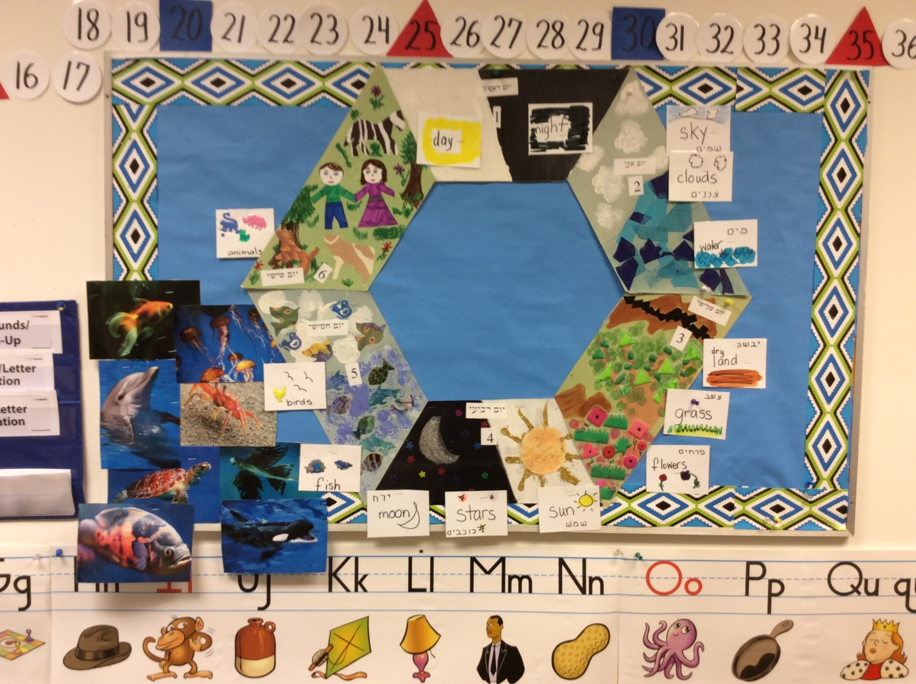
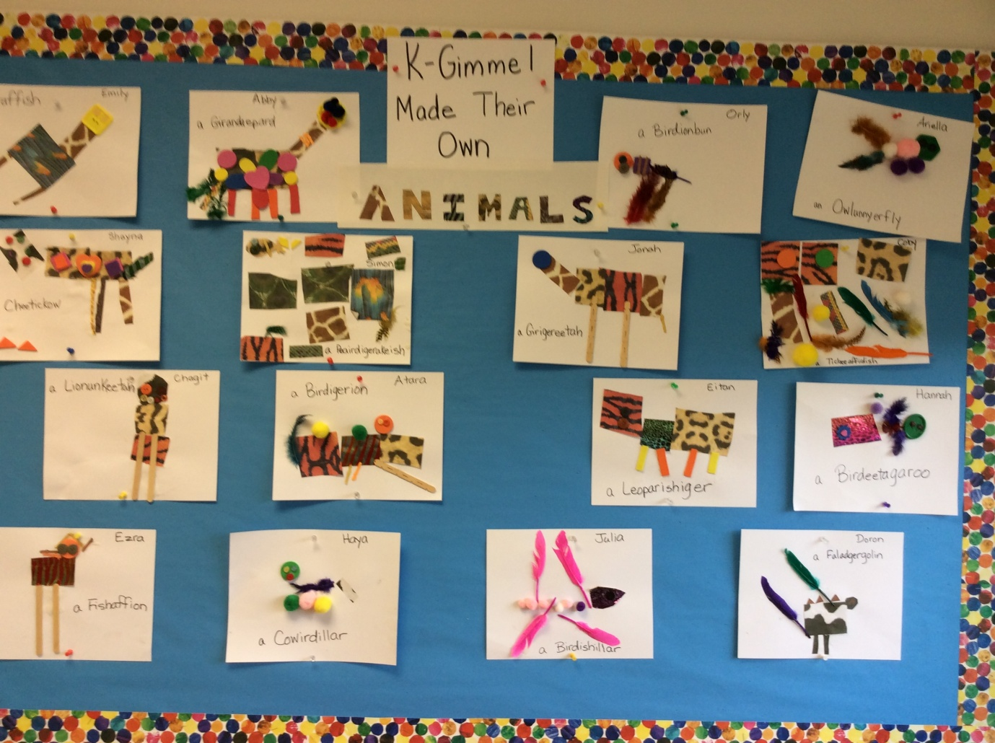

Animal Clue Book
written and illustrated by
K-Gimmel
