**Day School Exchange Curriculum 2016**

*Day 1 at SAA: February 17, 2016*

Essential Question:

* How is giving to others a way of pursuing justice?

Objectives:

* Students will be able to compare and contrast the meaning of “tzedakah” and “sadaqa”
* Students will be able to explain the importance of giving in each tradition
* Students will be able to examine the relationship between giving and justice
* Students will be able to implement Jewish and Muslim values (live their values)

|  |  |  |  |
| --- | --- | --- | --- |
| Sinai Akiba Day 1  (Wed Feb 17 2015) | Activity Goal | Time  Total time: 2 hrs 40 minutes | Location |
| Ice-breakers/Relationship building  Student-Council Welcome | To build positive relationships through the exchange with students of the other faith | 9:45-10:10 | Zeigler |
| Prayer observation  and discussion  (Just 7th grade) | To explore similarities and differences in each religion’s prayer traditions  To enhance learning of established curriculum on comparative religions | 10:10-10:45 | Kohn Chapel |
| Recess/Snack/School-tour | To build positive relationships through the exchange with students of the other faith | 10:45-11:05 | Zeigler |
| Parallel Learning Blocks 1 and 2 | To understand commonalities between themselves and students of the other faith, as well as the diversity within the other community.  To build positive relationships through the exchange with students of the other faith | 11:05-1:05 | Zeigler and Lower Traub |
| Lunch | To build positive relationships through the exchange with students of the other faith | 1:05-1:35 | Gym/ Zeigler |
| Wrap Up and Debrief the day | To cultivate a respect for diversity and dispel stereotypes  To enhance learning of established curriculum | 1:35-1:45 | Zeigler |

**Ice Breakers and Welcome** (9:45-10:10)

* Students sit on the floor in a circle with advisory group. Students sit next to buddies and put on name tags.
  + 7A (Red) with Shara Peters
  + 7B (Blue) with Aileen Level
  + 7C (Green) with Daisy Perez
  + 7D (Purple) with Ali Hurwitz-Kelman
  + 7E and SC (Orange) with Kevin Golden
* In the center of the circle put a poster with the word “Community.”
* Each student gets three sticky notes. Each student writes on each sticky a community (or group) that they are a part of (examples: sports team, Jewish community, school community, Los Angeles community etc.)
* After students have placed their sticky notes on the poster, ask them to rearrange the stickies so that similar stickies are grouped next to each other.
* Debrief the activity:
  + Looking at all of these stickies and the communities we feel a part of, how would you define “community?”
  + What communities do we - Jews and Muslims -- have in common? (Los Angeles, America)
  + If we are all part of the Los Angeles community, why is it that we are only meeting for the first time?
  + What other groups in Los Angeles might we not know or try to get to know on a regular basis?  [homeless, veterans…]
  + Why might there be groups in Los Angeles that we don’t know and don’t try to get to know? [proximity, focused only on one community, not thinking about stepping outside comfort zone, routine.]
  + Why should we care about all of the people who live in Los Angeles? What do you know about Judaism or Islam that emphasizes the value of caring for all people?
* Student council welcomes New Horizon and introduces guidelines and essential questions for the day
  + Be respectful
  + Be open-minded
  + Ask questions
* If time, play name-game ice breaker (name and action)

During opening activity, students discuss the meaning of “community.”

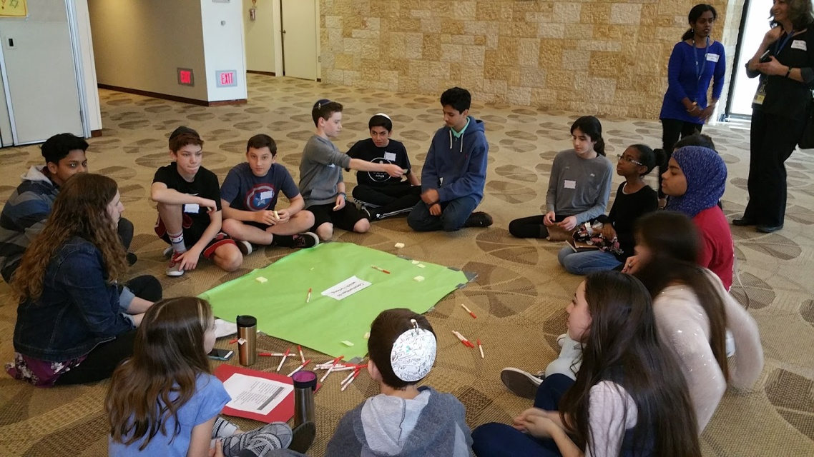

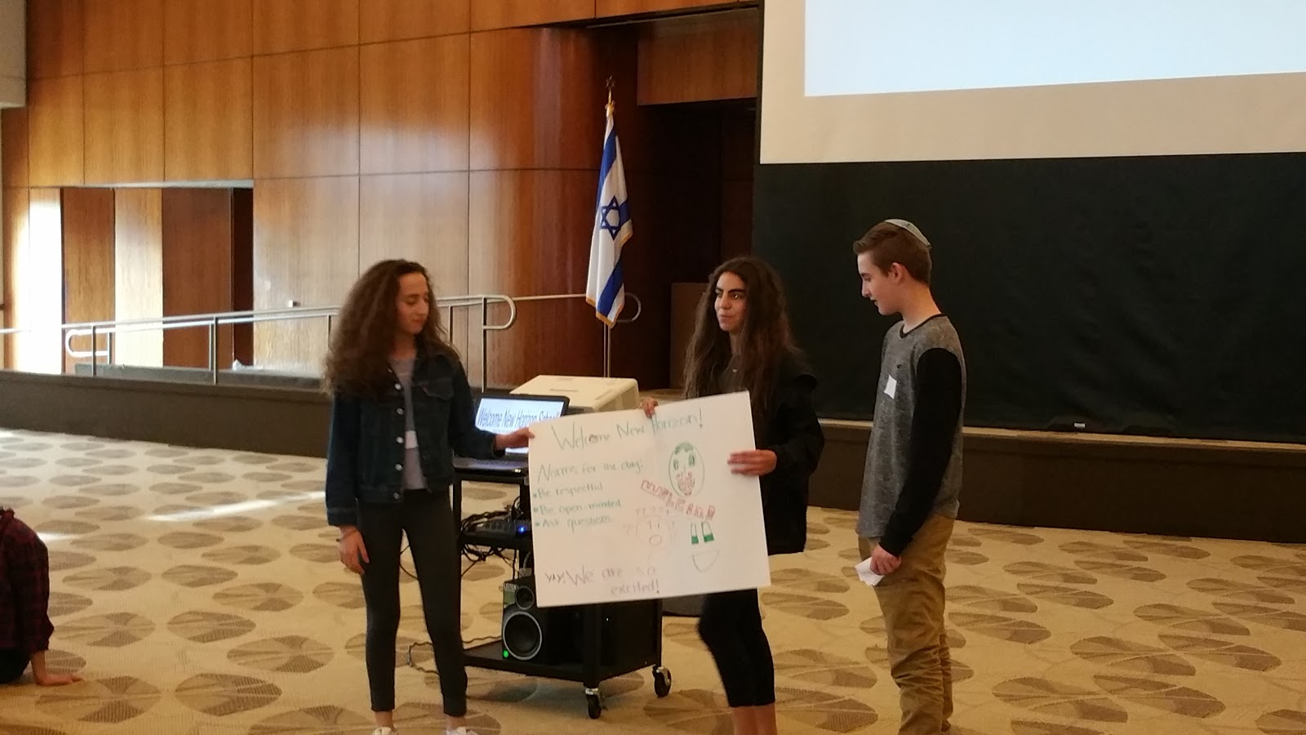

SAA Student Council welcomes NH students.

**Prayer Experience** (10:15-10:45)

* Students sit with their buddies
* 7th  grade only. 15 minutes t’fillah, 15 minutes question and answer session. Sample questions to ask students. Students should also ask their own questions:

o   What messages or ideas were discussed in the prayers?

o   What do you notice about the choreography of prayer (Standing, sitting etc.)?

o   What was the music like? Instruments? What might be the purpose of singing verses just reciting the prayers?

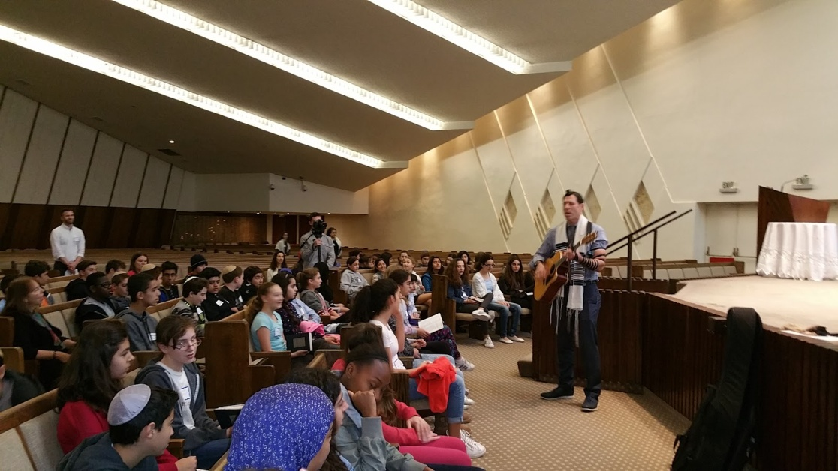

SAA and NH students pray together in the sanctuary.

**Learning Block 1: Giving to our Community -- Supporting Los Angeles’ Homeless** (11:05-12:05 or 12:05-1:05)

Part I: Interactive text study (20 minutes)

* Students sit at tables with their buddies.
* Warm up: Individually, students answer the following questions on a sticky note and post on wall:
  + In both Judaism and Islam, we give to others in so many ways.
    - How do you define “giving?”
    - In your opinion, what is the best way to give to someone in need?
* Facilitator reads out some answers: We’re going to see how each of our traditions defines giving and the best way to give. We’ll see what we might want to add to this poster.
* In buddy pairs, students will read the following texts, answer questions and do the following activities:

Text 1: Maimonides’ ladder of giving (Jewish source)

Maimonides, a 12th century Jewish commentator and philosopher, created a ladder showing levels of giving.

Eighth Degree: *“Gives Unwillingly”:* Lowest on the ladder is a person who gives only because he/she is forced to do so.  This is the gift of the hand but not of the heart.

Seventh Degree: *“Gives Less Than He Should, But Cheerfully”:* The person who gives less than he/she ought to, but with a smile.

Sixth Degree: *“Gives After He is Asked”:* The person who gives cheerfully and as much as he/she can, but only after being asked.

Fifth Degree: *“Gives Before He is Asked”:* The person who gives before he/she has been asked, but who puts it into the poor person’s hand, embarrassing him/her.

Fourth Degree: *“Giver Does Not Know Receiver”:* The poor person knows from whom he/she takes but the giver does not know the receiver. For example, there were men who tied money in the corners of the cloaks they wore, so that the poor might take it without being seen.

Third Degree: *“Receiver Known, Giver Unknown”:* One who knows to whom a person gives, without the poor knowing from whom they receive. For example, in olden days, our ancestors brought gifts into poor people’s homes and left without being seen.

Second Degree*: “The Giver and Receiver Unknown to Each Other”:* One who gives charity to the poor without knowing to whom he/she gives and without the poor knowing from whom they take. This is how it was done in the Lishkat Hashaim (Chamber of Charity) in the Temple of Jerusalem.

First Degree: *“Help a person Help Himself/Herself”:* Prevent poverty by giving someone a gift or a loan or finding work for him/her so that he/she will not need to appeal for help. This is the top rung of Tzedakah's golden ladder.

*Questions for discussion:*

* Underline the part of Maimonides’ Ladder that describes the ways that you usually give.
* Soon we will be packaging hygiene kits for homeless people in Los Angeles. Which degree of giving do you think hygiene kits would fall on Maimonides’ ladder of giving? Circle your answer in the text. Be prepared to explain why.

Text 2: “Giving continuously (beyond your life)” (Muslim source)

“When a person dies, his works end, except for three: ongoing charity, knowledge that is benefited from, and a righteous child who prays for him.” [Muslim, Tirmidhi] In Islam the idea of giving does not stop with one’s death. The best charity is that which continuously benefits people, such as helping to build a school, a clinic, or a water supply system, or helping a poor person start up his own business. This hadith means that any good you do that benefits people will also benefit you even after you die.

Questions for discussion:

* Underline in the text: According to Islam, what is the best way to give so that your gifts continue even after you die?
* Discuss: How is the Muslim text above similar to the Jewish text by Maimonides?

Reflect on both texts: What is one big idea about giving according to Islam or Judaism?

1. Write your answer in one of the squares below.
2. Give One, Get One: Talk to three different students who attend the other school and record their answers in the remaining three squares. Share your answer with them.

|  |  |
| --- | --- |
|  |  |
|  |  |

Whole-group Debrief:

* What do you notice about the similarities between Muslim and Jewish traditions regarding how we are supposed to give and the best way to give? (Give without embarrassing someone, give without being asked give so that gifts are sustainable and encouraging self-sufficiency -- loans, build school, employment etc.)
* Look back at your warm-up. After reading Muslim and Jewish texts about giving, what would you add to your definition?

Part II: Andrea Murray and Johnson Family from PATH -- speaking about homelessness (20 minutes)

Part III: Packaging hygiene kids/card-making (15 minutes)

Each student will create 1 hygiene kit and make a card to go inside the bag. Last group of students can make extra kits using the leftover supplies. (Students collected hygiene items in the month leading up to the Exchange.)

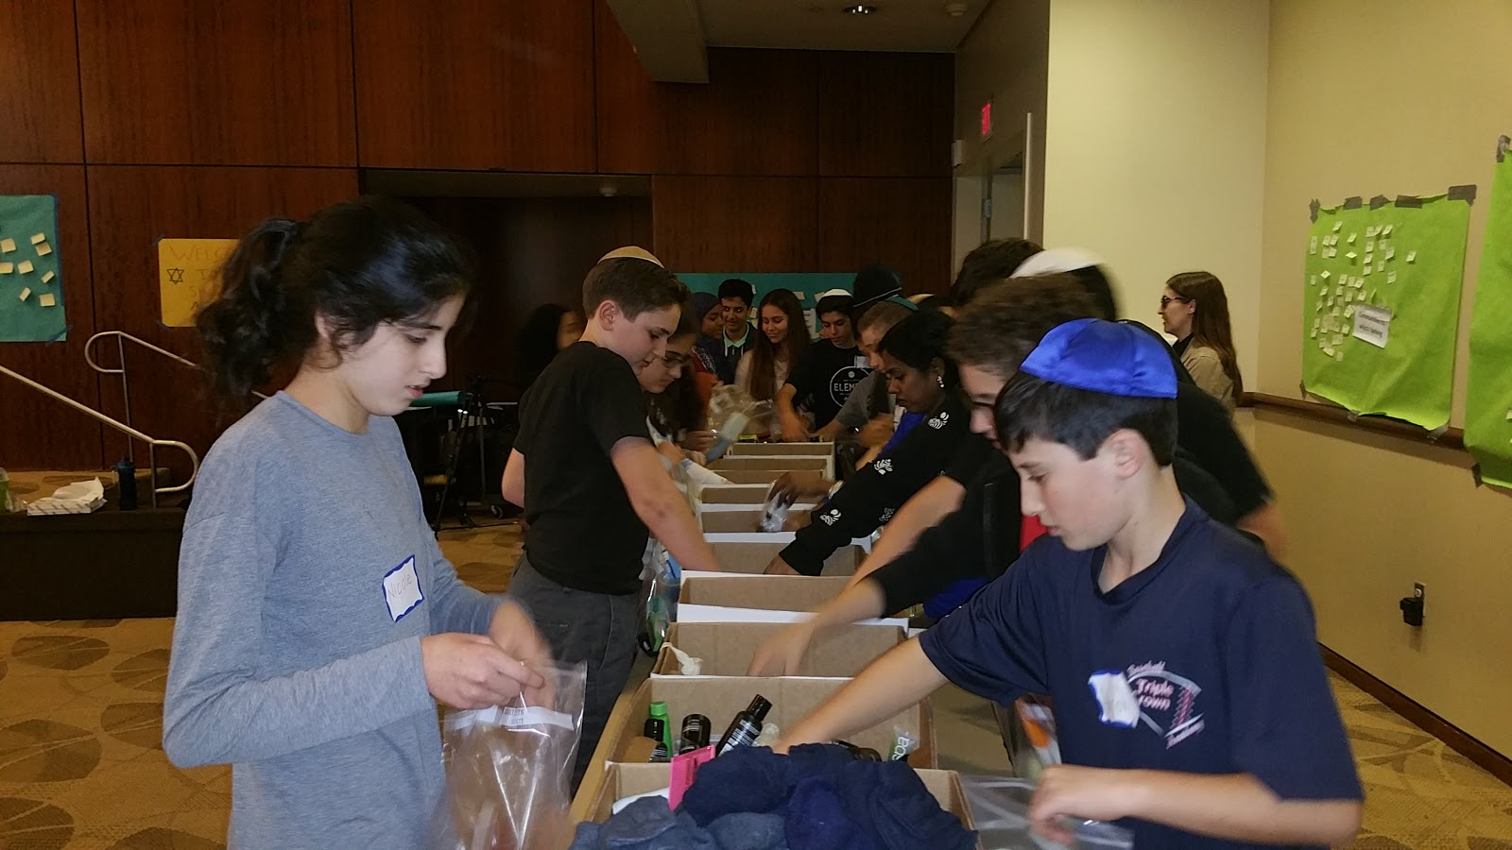

Muslim and Jewish students working together to package hygiene kits for the homeless.

**Learning Block 2**: Text study and Mural Art (11:05-12:05 OR 12:05-1:05)

1. Text study (15 minutes)

Read text whole-goup

Discuss texts in pairs/tables

Come back together to share

Text 1:

*The word “charity” comes from the Latin word “caritas” which means loving and caring.  The Hebrew word tzedakah comes from the root* Tzedek *which means righteous or just.  Charity is a matter of feeling; tzedakah is a matter of obligation.*

--Yad, Hilkhot Deyot 8:1

Text 2:

*The Arabic words for charity are: Zakat, which means to purify and  Sadaqah (from sidq, meaning truth). Zakāt, one of the five pillars of Islam, is a fixed portion of one's wealth which it is obligatory to give away annually for the benefit of the poor.  Zakāt is a tax which is different from voluntary charity.Zakāt  is the most important obligation next to prayer.  Sadaqah is the voluntary charity which takes on various modes.*

Questions for Discussion:

* Texts 1 and 2: How are the two forms of giving in Islam similar to tzedakah? How are they different than tzedakah? (Venn Diagram)
* Texts 1 and 2: How might giving to those in need through tzedakah, sadaqua or zakat be a way of pursuing justice (a way of making the world better/more fair?)
* Your brain: Brainstorm and record a list of words or symbols you might use to show the Jewish and Muslim ideas of what it means to give.

(Examples: a hand, peace sign, the word sadaqua in Arabic, the word tzedakah in Hebrew, justice etc.)

2. Making the mural (45 minutes)

Note: Provide a word bank with key words in Hebrew, Arabic and English

* ·Each person will receive a metal square
* Students design their square using words and symbols that represent what Jews and Muslims believe about giving
* Tiles will be put into a mural. One mural for each school.

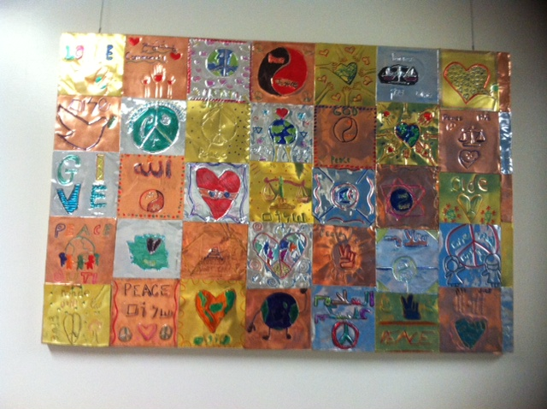

Finished mural, currently hanging in Sinai Akiba’s entry hall, created by SAA and NH students February 2016.

(New Horizon school has a similar mural hanging at their school)

**Lunch 1:05-1:35 -- Pizza, carrots, cookies, drinks provided**

**Wrap up and Debrief the day 1:35-1:45**

* Sit in a circle with table groups. Students write reflections to the following questions on a notecard:. They can choose 2 or more questions to answer.

1. What did you know about your buddy and/or about Islam/Judaism before meeting today?
2. What did you learn about your buddy and/or Judaism and Islam?
3. What do you still have questions about?
4. How has today’s experience affected you?

* Teacher facilitators call on a few students to share something new they learned or a question they still have
* Whip around: In one word, how would you describe our morning together?

(Go to next page to see plan for day at New Horizon)

Day 2 at New Horizon School – March 16 2016

**Giving to the Earth**

|  |  |  |  |
| --- | --- | --- | --- |
| **NHS Day** | **Activity Goal** | **Time**  Total time: 2 hrs 40 minutes | **Location** |
| Welcome and logistics | To build positive relationships through the exchange with students of the other faith | 9:45-9:50 | Adaya Auditorium |
| Introduction to the topic and the day | To understand the commonalities between Islam and Judaism  Students will be able to list three similarities and differences between Islamic and Jewish concept of giving to the earth | 9:50-10:15 | Adaya Auditorium |
| Recess/Snack & Scavenger Hunt | To build positive relationships through the exchange with students of the other faith  To demonstrate understanding of basic concepts in Judaism and Islam | 10:15 – 10:35 | MS Campus |
| Learning Activity  Parallel Session I | To identify and understand commonalities between themselves and students of the other faith, as well as the diversity within the other community.  To enhance learning of established curriculum on comparative religions | 10:40 – 11:30 | Maker Space and Science Lab OR Garden |
| Learning Activity  Parallel Session II | To identify and understand commonalities between themselves and students of the other faith, as well as the diversity within the other community.  To enhance learning of established curriculum on comparative religions | 11:30 – 12:20 | Maker Space and Science Lab OR Garden |
| Lunch | To build positive relationships through the exchange with students of the other faith | 12:25 – 12:50 | Lunch Area |
| Prayer Observation and Explanation & Q & A | To explore similarities and differences in each religion’s prayer traditions  To enhance learning of established curriculum on comparative religions | 12:55 – 1:10 | Adaya Auditorium |
| Reflections | To reflect on the impact of the visit as a learning experience in understanding similarities and differences in each faith tradition and in dispelling stereotypes | 1:10 – 1:20 | Adaya Auditorium |
| “Steal the Turkey Bacon”  Activity | To build positive relationships through the exchange with students of the other faith | 1:25 – 1:45 | MS Field |
| Board the Bus |  | 1:50 | MS Driveway |

Day Two: Giving to the Earth

1. INTRODUCTION & LEARNING SESSION – ADAYA AUDITORIUM (9:45-10:15)

* Students sit in chairs at round tables by advisory groups. Each advisory will have a color assigned to make it easy for Sinai buddies to find New Horizon buddies.  (Sinai teachers will tell students in advance which color to find).  Students will be provided special name tags with numbers on.
* Administration welcomes our guests to NHS and to the Peace Garden
* Mrs. Mehdi/ Student Council provide an introduction and outline for the day.
* Mrs. Mehdi uses a PowerPoint to introduce the topic for the day providing texts from Islam and Judaism on stewardship of the earth and preserving the environment.

***Texts:***

*JUDAISM (from Midrash Kohelet (Ecclesiastes) Rabbah 7:20)*

*Upon creating the first human beings, God guided them around the Garden of Eden, saying; ‘Look at my creations! See how beautiful and perfect they are! I created everything for you. Make sure you don’t ruin or destroy My world. If you do, there will be no one after you to fix it.’*

*ISLAM (from Qur’an)*

*It is We (God) Who sends down rain from the skies: with it We produce vegetation of all kinds: from some We produce green (crops), out of which We produce grain, heaped up (at harvest); out of the date-palm and its sheaths (or spathes) (come) clusters of dates hanging low and near: and (then there are) gardens of grapes, and olives, and pomegranates, each similar (in kind) yet different (in variety): when they begin to bear fruit, feast your eyes with the fruit and the ripeness thereof. Behold! in these things there are signs for people who believe…. But waste not by excess: for Allah loveth not the wasters. (6: 99-141)*

* Students work together in groups to discuss and record thoughts about how our faiths promote stewardship.
  + Discuss with your group the ways we can help preserve the earth.
  + Discuss how your faith supports your role as a steward.
  + Record your ideas on the chart paper at your table.

1. RECESS & INTERFAITH SCAVENGER HUNT -- MS CAMPUS (10:15-10:35)

* Students go with their buddy groups – recess + scavenger hunt
* Teachers roam around monitoring students making sure they are taking turns answering the questions and staying with their buddy groups
* NHS/SAA staff call students to go to the Learning Sessions

**Student division for the parallel sessions:**

10:40am

1- Maker Space

2- Science Lab

3- Amphitheater (Sustainability Practices- 20 mins then switch with #4)

4- Amphitheater (Working in the Garden- 20 mins then switch with #3)

11:30am

1- Amphitheater (Sustainability Practices- 20 mins then switch with #2)

2- Amphitheater (Working in the Garden- 20 mins then switch with #1)

3- Maker Space

4- Science Lab

1. LEARNING ACTIVITY PARALLEL SESSION I – Maker Space & Science Lab

(10:40 – 11:30) AND (11:30 -- 12:20)

***Maker Space -- Ms. Heba and Mrs. Shah***

***Lab -- Mrs. Mehdi and Mrs. Ansari***

* Students go with their buddies
* Objectives -- Students will be able to:
  + Use their creativity and imagination to make a design on a rock or tree cookie to add to the garden space using the themes of peace, nature, faith, etc.
  + Write a prayer for peace to place in the garden.

1. Facilitator: “In the beginning of the day we talked about the importance of taking care of the environment in both our faiths and in this activity, you will have the chance to use your creativity and imagination to paint a rock or tree cookie with a design that will add to the beauty of our garden space and represent our work as interfaith partners.  We will also take some time to think about a prayer for humanity or the earth that we can write on crepe paper and later hang from our fig tree.” [show students where they can find the materials for these two activities]
2. Facilitator should put the themes of peace, nature, beauty, faith on the board to remind students what should inspire their art work.
3. Direct students to the area behind the classroom to pick a rock or tree cookie and bring it back in to paint.  They can use a piece of paper to sketch some ideas before they start working.
4. Students work together to add their art to these natural elements that once they are dry, will go into the garden.
5. Students should also make time to write their prayer on the crepe paper.
6. When students are finished, they can put their rocks back outside to dry, and they must help clean up their areas.  Make sure to leave the last 5 minutes for cleaning up.
7. LEARNING ACTIVITY PARALLEL SESSION II – GARDEN (10:40 -- 11:30 AND 11:30-12:20)

*Sustainability Practices -- Ms. Tahereh/ Mrs. Satya*

*Working in the Garden -- Mr. Isaac/ Mrs. Satya*

*Contemplation Circle (concluding activity) -- Mrs. Al-Sarraf*

**Objectives:**  Students will be able to:

* + appreciate their natural surroundings by working together in the NHS Peace Garden
  + identify sustainability practices for the environment (specifically water conservation)

**ACTIVITY:  Giving to the Earth**

* Students are in their 2 main groups and will have the chance to simultaneously be in stations 1 and 2 for two consecutive 20-minute periods (switching after 20 minutes)

*Station 1 -- Sustainability Practices (20 minutes)*

* Tahereh teaches students about the dry arroyo and mulching and how these features impact water harvesting.  Students are taken on a tour of these parts of the garden.

*Station 2 -- Working in the Garden (20 minutes)*

* Isaac shows students how to make peace seeds and how to shovel mulch throughout the garden

*Concluding Prayer Activity (10 minutes)*

* Both groups congregate near the Contemplation Circle and form a circle to be able to share a prayer together for peace and harmony in our world and to thank our friends for their help in the garden.

LUNCH – MS LUNCH AREA (12:25 – 12:50)

1. PRAYER OBSERVATION AND EXPLANATION / Q & A – ADAYA AUDITORIUM (12:55-1:10)

* NHS students demonstrate prayer while SAA students observe.
* NHS students provide explanation.
* SAA students ask questions.
* Mrs. Mehdi asks students to note what is similar and different between the prayers – all students can answer.

1. REFLECTIONS (1:10 – 1:20)

* Chart paper out on the tables with markers.
* Students write on chart paper what they learned from the visit, how the faiths are similar, and overall take-aways. Select a few students to read their responses out loud.

1. OUTDOOR GAME – MS FIELD (1:25-1:50)

* Students play “Steal the Turkey Bacon.”

1. STUDENTS BOARD THE BUS! (1:50)