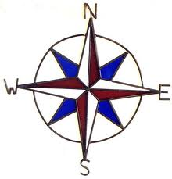Cartographer______________
Show Me the Way!
Mission: 2Y is expecting an important guest. Help our visitor feel welcome. Write the direction s/he must walk to find each of the items below. Use our COMPASS ROSE to help guide you.
Item Direction
(North, South, East or West)
SMART board

blue table

notebook bins

*classroom library

green table

word wall

fish tank

Help DESIGN a map key for our special visitors. Choose four items from the chart above and draw symbols to represent them.
A Map Key of 2y

