Using the Design Thinking model, the students have begun planning the creation of our community library. Based on research the children have done with our interviews, the students recognized the need for many adjustments to our library. Some of the key components the children noticed are all regarding the physical layout including a comfy area, an island to house books and displays, and an area in the fireplace with student-made books. After establishing these needs and empathizing with the users in the community, each class is currently in the process of prototyping these constructions. The Gan Tmarim are challenged with the task of designing a new comfy area. Today we took some time to think about different comfy areas we have sat and read in before. We talked and looked at pictures of the comfy areas from our field trips and had a chance to look at some different comfy areas at libraries from all over the world. We asked the question, “What does a comfortable area need?” (The children shared that they like the word “comfortable” better than “comfy”) The children shared we need a sitting or laying space, a fluffy/squishy/soft area, it has to be for reading, and it has to be close by books to grab them easily. Our next step will be ideate, to come up with our creative solutions.
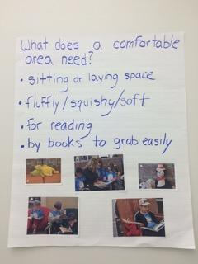

This morning we finished sanding the wood pieces that will be our library labels to make them smooth (picture of Lani above).

Today we continued in the design thinking process creating our comfortable area. (For more information design thinking you can check out: https://edudisruptor.files.wordpress.com/2012/08/chart3.jpg. We started in the Ideate process as we brainstormed all of our out of the box ideas about our Kikar library comfy area. Some idea included:
• Slides from the Ulam going into a reading ball pit into the Kikar
• Creating a reading tunnel from class to class
• Making different comfy areas for people to read with partners and to read alone
• Blue and white JPDS Panda stuffed animals as reading buddies on comfy large pillows

After our brainstorming session, we provided time for the children to put their ideas in action.
By providing an array of materials, the children created their own comfy area prototypes.
Check out their amazing and detailed work.
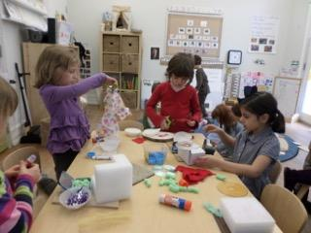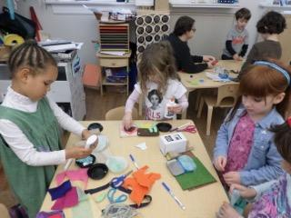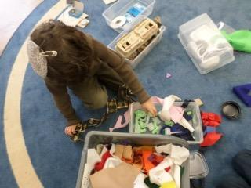

For our comfy area the children are making a blanket and a pillow. Here is David is sewing our green pillow!

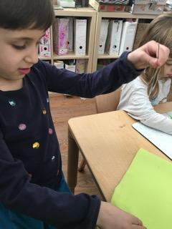
We painted out library sign! Pictured above is Kylee painting the word “library”.
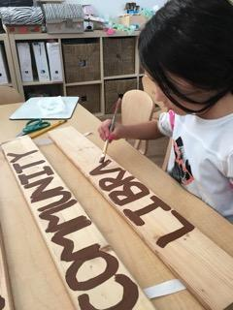

A small group of children met with Mrs. Davis to share our ideas about the comfy area. We explained our ideas about the different shared areas and alone spaces. We specifically focused on two topics: if want pillows and blankets and how can we create pits to sit in. We invited Mr. Ross into the conversation when the children had an idea to cut a hole in the Kikar floor to put a pit inside. When we decided as a team that we cannot put a hole in the kikar floor, Mrs Davis shared, “Based upon what I’m hearing, you want something comfortable and fun.” Noah remembered when we looked at stacking chairs that looked like pits before break. We all loved that idea and called them “above ground pits”.

After our conversation with Mrs. Davis, our next step was to measure! Kylee and Flora measured the different areas in order to make and buy our new library comfortable area pieces, and recorded their research.
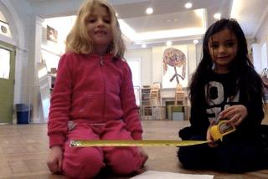

Today a small group of children met with Mrs. Davis to share our ideas about the comfy area. We explained our ideas about the different shared areas and alone spaces. We specifically focused on two topics: if want pillows and blankets and how can we create pits to sit in. We invited Mr. Ross into the conversation when the children had an idea to cut a hole in the Kikar floor to put a pit inside. When we decided as a team that we cannot put a hole in the kikar floor, Mrs Davis shared, “Based upon what I’m hearing, you want something comfortable and fun.” Noah remembered when we looked at stacking chairs that looked like pits before break. We all loved that idea and called them “above ground pits”.

After our conversation with Mrs. Davis, our next step was to measure! Kylee and Flora measured the different areas in order to make and buy our new library comfortable area pieces, and recorded their research.

