Prototyping the South Campus Library

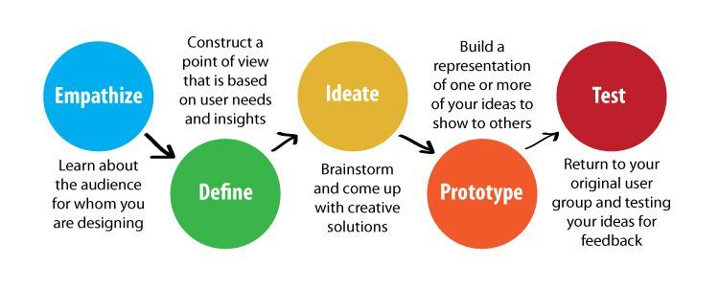
The Kindergarten has been exploring community, and as part of this exploration, Kindergarten noticed a need for an updated South Campus Library. This created an opportunity to better understand our own community by interviewing each community member and finding out how they use the library. Using the Design Thinking model, the students have begun planning the creation of this community library. Based on research the children have done, the students recognized the need for many adjustments. Some of the key components the children noticed, all regarding the physical layout, that we need to add to the South Campus Library include a comfy area, an island to house books and displays, and an area in the fireplace with student-made books. After establishing these needs and empathizing with the users in the community, each class is currently in the process of prototyping these constructions.

