Multiple Drafts and Peer Critiquing

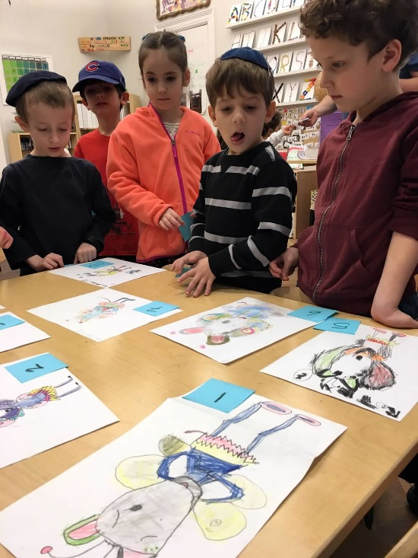
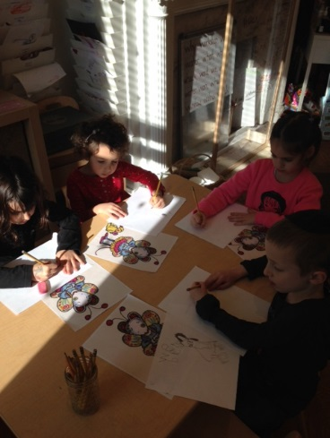
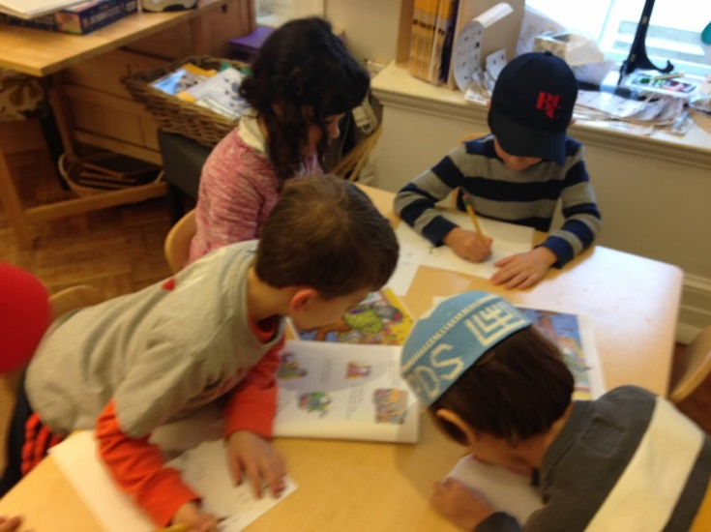
Inspired by the video “Austin’s Butterfly,” the Kindergarten focused on creating multiple drafts of work though attention to detail and peer critiquing. Each class created multiple drafts of different things-all with the same skills in mind. As children were creating their drafts, they were encouraged to slow down and pay attention to the detail in the item they were drawing. Once a draft was finished, peers gave specific critiques on how their good drawing could be better. Children then used these critiques to create a second and, at times, a third draft-each time going through the critiquing process. Positive peer support enabled the children to feel comfortable and confident with receiving feedback on what they had created. With each new draft, children noted their improved ability to capture more realistic versions of what they were drawing. Because of this process, the “simple” act of drawing became more meaningful, and a melding of executive functioning (planning), art, and science.

