Critical Thinking in a Bible Study Class

It was 11:43. Lunch began at 11:45. We hadn’t finished the lesson or packed up our belongings. I looked up at the clock.
“Lunch is in two minutes,” I explained to the class.
“We don’t care about lunch.”
“We’ll skip lunch.”
“Can we please continue learning?”
This was the second time that school year that the students made such an offer. Despite the pressure and enthusiasm from the students, I denied their request.
“You’ll find out the answer tomorrow.”
We were studying the story of Joseph and his brothers. The students were familiar with these stories since kindergarten. However, revisiting the story with a strong focus on critical thinking in fifth grade made the story come alive and elicited a sincere desire to learn.
The yeshiva day school students are taught the stories of the Bible since preschool, and often these stories are reinforced at home. Educators must use techniques to help the students analyze the material on a new level and from a fresh perspective. I believe that Bible study is the richest discipline that the students are exposed to. Creative and critical thinking transforms the learning experience from familiar, elementary stories into enriching and thrilling analysis.
Due to the succinct text of the Torah and Prophets, which tends to be void of most emotions, class instruction lends itself to strong focuses on critical, creative and analytical thinking. Critical thinking skills can and must be developed at any age. I will highlight 5 of the most effective creative and critical thinking skills that I consistently employ in my Bible study classes at multiple educational stages. I have used these techniques in classroom settings for grades 2-8, as well as in informal adult education classes. All worksheets which are referenced in this work are translated into English. They can be viewed in their original, Hebrew format in the Appendix.

Technique #1: Giving your Own Opinion of what the Characters...
Technique #2: Providing Support for an Answer with Proof from…
Technique #3: Examining Opposing Sides of an Issue, Conflict…
Technique #4: Analyses of Rashi’s Commentary
Technique #5: Compare and Contrast
Appendix: Original Worksheets
Technique #1: Giving your Own Opinion of Characters’ Thoughts and Emotions
I use this technique frequently and at all grade levels. Once a text is covered, we immediately begin to analyze what the characters were thinking or feeling. This helps the students understand and analyze the words or specific actions of the characters. This technique brings excitement, emotion and feeling to the text. It makes the characters relatable and relevant to students’ personal lives, as they are forced to identify with them.
When the students need to guess what the characters were thinking or feeling, it compels the students to project their own experience into the text and to “stand in their shoes.” This contributes to students’ ethical development. They become skilled at taking another's perspective. Students are able to empathize with Biblical characters and understand how their actions impacted others. This techniques gives students the opportunity to discuss social dynamics in a non-judgmental way.
In second grade, I also use this technique to expose students to the idea of different styles and opinions in Biblical exegesis. The students are asked to record their own answers and then write down the answer of another classmate. This teaches them that there is more than one correct answer to a question. This is a foundational idea in Rabbinic Bible interpretation and in literature. I highlight that different people come up with different answers and arrive at different conclusions.

Example #1: Prelude to the Deluge in Noah’s Time
Example #2: G-d Sends Moses to Tell the Israelites about…
Example #3: The Relationship between King Saul and Jonathan,...

Example #1: Prelude to the Deluge in Noah’s Time
When the students study the story of the Deluge in the second grade, they are already familiar with the story of the great flood and Noah’s Ark. They can recall that the people “were so bad that G-d wanted to destroy the land.” However, they can not explain which actions were so deplorable that G-d desired to wipe them out. Before we learn their sin, the students are first asked to analyze the situation from their own perspectives.

In their workbooks, the students received the following selection:

What do you think the people did that was so bad that it made G-d upset?
My answer:
__________________________________________________________________________________________________________________________________________
__________’s answer:
__________________________________________________________________________________________________________________________________________
What do you think is the worst thing that people can do? Explain why you think so.
My answer:
__________________________________________________________________________________________________________________________________________
__________’s answer:
__________________________________________________________________________________________________________________________________________

When lesson planning for second grade, I constantly employ this technique. The students greatly enjoy sharing their opinion and enjoy hearing their classmates’ opinions. Since they are required to first record their own answer, each student is forced to think about the information.
Students in 2nd and 3rd grades demonstrate excitement when given an assignment like this. When I ask 4th, 5th, or 6th graders to project their own opinion, some students consistently leave these questions blank. They are not comfortable with risk taking and giving their own opinion, for fear that they may be wrong. Occasionally, some students refuse to give an answer when asked for their own opinion and withdraw from the class. Other students feel comfortable writing down answers, but are inhibited from sharing their thoughts with their classmates.

Example #2: G-d Sends Moses to Tell the Israelites about Impeding Salvation
This selection is taken from a 5th Grade unit. When G-d instructed Moses to save the Israelites, He commanded Moses to remind the Israelites of the Covenant of the Parts. In the Covenant of the Parts, G-d told Abraham that his children would be slaves for 400 years in a foreign land. However, at the end of the slavery, G-d explained, He would judge the nation that enslaved the Israelites and they would leave with many possessions.
In Exodus, Chapter 6, verses 2-8, G-d sent Moses to deliver this message to the Israelite nation. Here, Moses specifically makes mention of the Covenant twice.
In their workbooks, the students are asked:

- A. How many times do verses 2-8 mention the Covenant? ______________
B. Summarize the Covenant.
________________________________________________________________________________________________________________________________________________________
C. In your opinion, did the Children of Israel think about this Covenant during slavery? Explain your answer.
_______________________________________________________________________________________________________________________________________________________

In this selection, the students are still asked to attribute emotions and feelings to the characters that they are learning about. However, they are asked to examine a specific situation and evaluate whether or not the slaves thought about the Covenant between G-d and Abraham and wondered when their salvation would arrive. They are not just being asked to evaluate the characters, but the thoughts of the characters as well.

Example #3: The Relationship between King Saul and Jonathan, his Son
This selection is taken from an exam from 7th grade unit on Samuel. The students covered the stories of the beginning of the reign of King Saul. During one of the Philistine wars, King Saul banned his soldiers from eating. His son, Jonathan, criticized him for this in front of the people. When Saul found out that Jonathan had eaten before the conclusion of the war, he was ready to put Jonathan to death.

On their tests, the students received the following question:

Describe the relationship between Saul and Jonathan. Do you think they were close? Do you think they respected each other? Your answer must be at least 4 sentences long. Give examples to support your answer.
____________________________________________________________________________________________________________________________________________________________________________________________________________________________________

Here, the students are asked to give their opinion of the feelings of both Saul and Jonathan. Based on the comments that both Saul and Jonathan made about one another, the students have a basis to evaluate this father-son relationship and assign feelings to each character. This technique can also be used on exams as a way of fully assessing if the students mastered each character.

Technique #2: Providing Support for an Answer with Proof from a Text
Beginning in the third grade, students are asked for their opinion along with support for their opinion. Once we study a text, I often ask the students to use the text to support their answers. They cannot only rely on memory or opinion, rather they learn to substantiate their beliefs by providing supporting proof. They learn that if they want to express an opinion, they need to have proof. This helps develop their critical thinking skills.
The students are taught to analyze their own thought process and ask themselves how they will provide proof for their answer. The students figure out which texts best provide support for their answers. In younger grades, I direct them towards specific verses where they will likely find support for their answers. As they become more confident and proficient at successfully providing support for their answers, the expectations rise. Older students are not told which verses to look in. They are also asked which specific words provide support for their answers and cannot include extraneous words in the phrases they quote.

Example #1: The Binding of Isaac
Example #2: Samuel I: Chapter 1
Example #3: The Spies Moses Sent to Scout the Land...

Example #1: The Binding of Isaac
When covering the story of the Binding of Isaac in a third grade classroom, I used various critical thinking techniques. This example illustrates that the students are asked to give their opinion of the feelings of the characters and provide support for their answers from the text. In this example, the students have learned that Abraham and Isaac were walking to the site where Isaac would be bound. Isaac suspected that something was amiss and asked Abraham where the sacrificial sheep was. Abraham responded, “G-d will show us where the sacrificial sheep is, my son.”

In their workbooks, the students were assigned the following page for homework:

- In your opinion, when did Isaac understand that he would be the sacrifice? Explain.
- How can we learned about the righteousness of Abraham and of Isaac from Verse 9?

The Righteousness of Abraham | The Righteousness of Isaac

3. In your opinion, what was ___________ thinking about at this time?

The Thoughts of Abraham | The Thoughts of Isaac

Here, the students are given the specific verse to find support for their answer. After first being asked to defend when Isaac understood that he would be the sacrifice, the students have an easier time finding support for their answer to question 2. By first requiring the students to prove that both Abraham and Isaac were righteous, their answers to question 3 are framed in a more directed manner.
By placing their answers in a chart, it helps the elementary school students see two perspectives at the same time. It becomes easier for them to understand and appreciate the simultaneous experiences of both Abraham and Isaac.

Example #2: Samuel I: Chapter 1
This is a summative selection from a 6th grade Prophets test. The story in Samuel I: Chapter 1 is about people misunderstanding each other. We go person by person and explain how the actions of each characters were both good and bad, as well as hurtful and not hurtful. This supports critical thinking but also develops ethical development and interpersonal relationships. The first character the students were asked to evaluate was the High Priest, Eli. In his case, they were also required to provide opposing sides of the same argument.
- Evaluate the actions of the people listed below. You need to explain if their actions were good or bad. You must give an example to prove your opinion. It must be an action they did or said (not just their job)
- Eli (good and bad)
- Elkana
- Hannah
- Penina

Here, the students are required to give proof for their answers. Students who are proficient in Hebrew receive a differentiated test which asks them to quote from the text to provide support for their opinion.

Example #3: The Spies Moses Sent to Scout the Land of Israel
This selection is taken from a 7th grade unit on the Sin of the Spies in the Book of Numbers, Chapter 13. At the request of the Israelites, Moses hesitatingly agreed to send spies to scout the land of Israel before the conquest to conquer the land. G-d warned that the account of the spies would be skewed in a negative light, however He granted permission to send the spies, and one scout was chosen from each tribe. As G-d predicted, ten of the scouts gained negative impressions of the land. Only two scouts, Joshua and Caleb, had positive impressions of the land.
In this lesson, we covered two commentaries of the Biblical exegete, Rashi. These commentaries highlighted that Joshua and Caleb were aware of the bad intentions of the other ten spies, so they separated themselves from the group. In this assignment, the students were asked to prove that Joshua and Caleb knew that the other ten spies had intended to speak negatively about the land of Israel. The students are asked to explain according to two separate verses.
In order to correctly give the answer, the students need to review Rashi’s commentary. Then, with the help of Rashi, the students need to show what hints are in the Biblical text that prove that Joshua and Caleb were aware of the negative intentions of the spies. Once the students figure out the correct information, they are required to quote the relevant proofs from Rashi’s commentary.

In their workbooks, the students were assigned the following question for homework:
- Prove that Joshua and Caleb knew that the spies had intentions to speak negatively about the land.
- According to Verse 22
_______________________________________________________________________
- According to Verse 23
_______________________________________________________________________

In their workbooks, this assignment appears both in Hebrew and in the unique Rashi script. The students are aware that when a homework page appears in Rashi script, it signals that the work covers Rashi’s commentary. Therefore, it is unnecessary to explain that this is an evaluation of Rashi.
In this selection, the assignment is multi-layered, as the students are required to synthesize two texts. The students must first understand the verses from the text of Numbers. Next, they are taught Rashi’s commentary. In their workbooks, there are charts provided which explain Rashi’s commentary clause by clause. By providing this resource for the students, they have the necessary tools needed to quote from Rashi’s commentary. Finally, they are asked to analyze Rashi’s commentary and prove that Joshua and Caleb had analyzed the spies and were aware of their intentions.
When given the Rashi charts, most students are able to succeed at this assignment. However, there are a number of students who feel that they are unable to complete such an assignment. I often need to preempt the assignment by explaining to specific students how to understand what the question is asking them and how to find the correct answer.
Additionally, when asked to quote from a text, some students do not feel that they understand Hebrew well enough to provide a supporting proof-text. In these cases, some students write their answers in English. When prompted, many students correctly find support from the text, although they often feel it is a belabored process. I continue to hold these students to high expectations and have been pleased with the growth that many demonstrate in their ability to correctly quote from the text.

Technique #3: Examining Opposing Sides of an Issue, Conflict, or Dilemma
One of my most successful techniques for retention of the material and student engagement is when the students are asked to analyze the material from opposite perspectives. This method is best used when the text describes a conflict or dilemma that someone is facing. By requiring the students to think about opposing sides of an issue, it forces them to master their basic understanding of the issue at hand. I use this technique at all grade levels.
Once the students identify with one side of an issue, they begin to defend their beliefs in the face of an opposing argument. The classroom often results in debate and deep discussion. In each case, the students are still required to bring support for their opinion, which further contributes to their passion when debating the issue. Students are first asked to write down each side of the argument in their workbooks before it is discussed in the classroom. This ensures that each student has had an opportunity to think about the material and draw their own conclusions.
Besides for contributing dramatic effect in the classroom, this also trains students to view a situation from more than one perspective. This is a valuable tool during their formative years of developing patience and understanding in their interpersonal relationships.
Example #1: Jacob Tricked Isaac in order to Obtain the…
Example #2: Joseph and Potiphar’s Wife

Example #1: Jacob Tricked Isaac in order to Obtain the Blessing of the Birthright
When learning about the conflict that Jacob experienced when Rebecca commanded him to trick Isaac in order to obtain the Blessing of the Birthright, students are presented with the dilemma that Jacob faced. After the class covered Jacob’s objections to Rebecca’s command, the students received the following question in their workbooks:
- In your opinion, what do you think Jacob thought about Rebecca’s words (plan)?
________________________________________________________________________________________________________________________________________________________
2. A. Write a reason that Jacob would listen to Rebecca.
___________________________________________________________________________
B. Write a reason that Jacob would not listen to Rebecca.
___________________________________________________________________________

Example #2: Joseph and Potiphar’s Wife
In fourth grade, the students are taught the story of the false accusations that Potiphar’s wife made against Joseph. During this unit, we examine her words closely and analytically. We discuss how Potiphar’s wife carefully chose her words in order to try and frame Joseph. Each time we studied an account that she told the servants of Potiphar’s house, as well as when she spoke with Potiphar, we discussed whether or not her accusations should be believed. The students gave reasons why her accusations should be believed and why her accusations shouldn’t be believed.
I have taught this unit consecutively for the past 4 years. Each year, the students’ overall performance on the exam for this chapter is stronger than their performance on other Bible exams. I strongly believe that the focus on examining one issue from opposing sides helps them retain the material.

On their exam, they received the following chart:

To Believe or Not to Believe?
Why should she be believed and why shouldn’t she be believed?
 | Believe | Not Believe
The Servants
Potiphar

Here, the students are asked to consider multiple perspectives of the same issue. They are required to fill in reasons Potiphar’s wife should be believed and doubted from the perspectives of the servants and Potiphar. While the technique is similar to that of what they were exposed to in third grade, they are now expected to consider various viewpoints simultaneously.

Technique #4: Analyses of Rashi’s Commentary
In the third grade, we begin to formally study Rashi’s commentary on the text. At the most basic level, students are trained to pay attention to words in the text that seem unnecessary or extraneous. They are taught that each word in the text serves as a hint to a deeper layer of meaning and are taught Rashi’s insights.
Once the students have been immersed in this understanding, they are then expected to analyze Rashi. We discuss how Rashi arrived at each answer and why Rashi felt that his answer best supported the text. At first it is challenging for the students to analyze Rashi and understand how he arrived at his answer. Once they become accustomed to analyzing Rashi’s train of thought, they, naturally and independently, notice the nuances in the text.
By fifth grade, we examine situations in which Rashi brought more than one answer. Here, we focus on many aspects of Rashi’s possible train of thought.
Whenever Rashi gives more than one answer, I ask students to explain:
- What drove him to bring an additional answer? What was insufficient with each answer that Rashi did feel it was a strong explanation to the question he was addressing?
- What is the support for each answer?
- What is the weakness of each answer?
- Of all the answers brought by Rashi, which answer seems most logical to the students?

Example #1: “The Son of his Old Age”
Example #2: Rashi in the Light of Other Commentators

Example #1: “The Son of his Old Age”
This selection is taken from a 5th grade unit covering the story of Joseph and his brothers. The text informs us that Jacob loved Joseph the most because “he was the son of his old age.” Rashi, as well as other commentators, attempt to explain the deeper meaning behind these words and explain how this helps us understand why Jacob loved Joseph more than his other sons.
In class, the students receive their workbooks in Hebrew. When learning Rashi’s commentary, the students receive a chart with Rashi’s text, broken down clause by clause. The table is printed in their workbooks in Rashi script. Independently, the students copy Rashi’s script into the table into regular Hebrew print. This is done to reinforce Rashi letters, which some students have not yet mastered, even in 7th or 8th grade.
Additionally, copying Rashi aids the students’ understanding of Rashi. Students who are fluent in Hebrew are able to understand the main idea of Rashi when it is broken down for them clause by clause. These students often try to translate the chart independently before it is taught to the class and help with the translation in class. After the class copies Rashi’s script, we explain the commentary clause by clause in English.
For the purpose of this work, the table below is already translated into English.

Rashi’s Commentary: Verse 3: “The Son of his Old Age”
 | Explain Rashi’s words: | Copy Rashi’s words:
- For he was born to him in his old age.
2. Onkelos rendered:
For he was a wise son to him-
Everything he learned from Shem and Eber,
He passed on to him.
3. Another answer:
For his features
Resembled his own.
Once Rashi’s commentary is fully explained, the class discusses each answer and fills out the next table.
What do the words “Son of his Old Age” mean?
1st answer: | 2nd Answer: | 3rd Answer:

Here, the students record each answer, as well as the strengths and weaknesses of each.
For homework, the students received follow-up questions:
- “The Son of his Old Age”
Explain according to Rashi.
____________________________________________________________________
2. In your opinion, which approach seems most logical? Explain why.
_______________________________________________________________________

After they have learned Rashi’s commentary and discussed all three approaches, they are then asked to analyze and record which answer makes most sense to them.
This exercise is challenging for the students when they are first exposed to analyzing more than one answer of Rashi. However, as the students become accustomed to analyzing Rashi and understand how he arrives at his answers, they willingly share their insights when Rashi brings more than one answer. If the students notice more than one answer when copying the Rashi charts, they immediately begin to analyze the strengths and weaknesses of each answer, without being prompted to.

Example #2: Rashi in the Light of Other Commentators
Another technique that is also used to analyze Rashi is comparing his approach to Nachmanides. When covering appropriate units in the fourth grade, the students are exposed to the commentary of Nachmanides. In the fifth thru eighth grades, I try to include a lesson on Nachmanides at least one time per unit.
Nachmanides’s commentary is well suited as a comparison to Rashi, as Nachmanides was well versed in Rashi’s commentary and quotes Rashi. Nachmanides lived after Rashi and often disagrees with Rashi’s approach. He also often explains his point of disagreement with Rashi. After we have learned both commentaries, the students are asked to guess what Rashi would have argued back in response to Nachmanides to defend his own answers.
This selection is taken from a sixth grade unit covering the “Sin of the Complainers,” in Numbers: Chapter 11: Verses 1-3. The verses explain that “the nation were like complainers in the ears of Hashem.” Hashem got angry with the nation and immediately sent a fire to consume the edge of the camp. However, the text does not tell us what the complaint was or why the people complained. Both Rashi and Nachmanides use clues from the text in Chapter 11 as well as information from Chapter 10 to fully understand what the complaint was.
Once both commentaries have been covered, the students received the following chart in their workbooks.

The Sin of the Complainers
“The nation was like complainers, bad in the ears of Hashem”
 | Rashi: | Nachmanides:
The Complaint:
Why did they complain?
What was “bad” in the ears of Hashem?
Proof from the text:

- What is your opinion of the commentaries of Rashi and Nachmanides?
________________________________________________________________________________________________________________________________________________________
- Which commentary do you prefer? Explain why.
________________________________________________________________________________________________________________________________________________________

In the table above the students are first asked to identify the complaint according to each exegete, as it is missing from the text. Then, they are asked to explain why the people complained about this issue. Next, the students need to explain why the complaint was “bad” and so upsetting to Hashem. Finally, the students are asked to record the textual basis upon which Rashi and Nachmanides base their opinions. After they have fully reviewed all the components of the complaint, from the perspectives of Rashi and Nachmanides, the students are asked which commentary they prefer.
Typically, the students tend to identify with the commentaries of Nachmanides. In these cases, the students are reminded that Rashi did not have an opportunity to defend his commentary to Nachmanides and the students are asked to step in and defend Rashi’s approach. The students enjoy this exercise very much and often explain that “Nachmanides is their favorite commentator.”

Technique #5: Compare and Contrast
This technique effectively creates drama and excitement in the Bible study class. I use this technique in various ways: by comparing texts, phrases and/or words, and characters. In each case, students of all learning abilities demonstrate that are able to follow the lesson and can appreciate what we are comparing.

Example #1: Comparing Texts
Example #2: Comparing Phrases and/or Words
Example #3: Comparing Characters

Example #1: Comparing Texts
This specific technique is used when one text does not contain all the details which are included in a latter text. For example, when studying the sale of Joseph, the text in Genesis: Chapter 37 provides minimal detail and Joseph is portrayed as a passive character who is overtaken by his brothers and thrown in a pit.
In Genesis: Chapter 42, we are told of the story of the brothers standing before Joseph in Egypt. While they had descended to Egypt to purchase food in time of a famine, Joseph accused them of being spies and they were imprisoned. While they were imprisoned, the brothers discussed their misfortune and concluded that while they were not guilty of being spies, they were guilty of their actions relating to Joseph for they “saw the pain in his soul as he begged them,” but they did not listen. This account describes Joseph as begging for mercy, while the brothers ignored his pleas.

In their workbooks, the students received the following assignment to be completed in class with a partner:

- Describe the scene of Joseph being thrown into the pit, according to:
Chapter 37 | Chapter 42  (Include all the new details)
2. What is the difference between the two stories?
___________________________________________________________________________
3. In your opinion, why don’t all the details appear in Chapter 37?
__________________________________________________________________________

Here, the students are asked to review the stories and evaluate why the details are missing from the first account.

Example #2: Comparing Phrases and/or Words
This technique demands a close reading of the text and understanding of the verses. Once the words and verses are translated, we are able to compare words which are used in one verse and changed in another.
This selection is from a seventh grade Prophets class on Samuel I: Chapter 21. David was running away from King Saul, who wished to kill David. King Saul’s servants and kingdom were aware of the order to kill David, and those who spotted David were required to report his whereabouts to King Saul. In this chapter, Jonathan, Saul’s son, explained to David that he needed to flee the city to protect himself. David ran to the city of Nov, where the Tabernacle stood. There, David hoped to find respite from Saul, however, Doeg the Edomite, one of Saul’s trusted officers, was also at the Tabernacle. When David noticed Doeg, he left the Tabernacle and went to the land of the Philistines.
When David left the city, per Jonathan’s instruction, the text states:
“He got up and he went.” (Samuel I: Chapter 21: Verse 1). However, after seeing Doeg, the text states: “He got up and he fled.” (Samuel I: Chapter 21: Verse 11).
In their workbooks, the students received the following questions for homework:
- A. Compare the actions of David in Verse 1 and in Verse 11.
Verse 1: ____________________________________________________________
Verse 11: ___________________________________________________________
B. Which word changed? ______________________________________________
C. In your opinion, why?
_________________________________________________________________________

Here the students are taught to compare a change in words in order to appreciate the experience of the character. The students appreciate these nuances and the manner in which they help us understand the text.
If students are not comfortable reading the text without assistance, these assignments are challenging for them. When the homework is reviewed in class, these students record the answers. However, since they have not independently analyzed the material, the comparison is not as meaningful to them.

Example #3: Comparing Characters
This technique is less challenging than comparing texts, as most students are able to understand the storylines and the characters we discuss. I have successfully used this technique in grades 2-8. On occasions that I taught the same students different subjects, I used this technique to analyze the character development of different personalities.
When teaching a sixth grade class, we studied the story of Moses, as G-d appointed him to be the leader of the Jewish people. We learned about Moses’ objection to his position and G-d’s response to him. We also studied King Saul during the study of Samuel I. Like Moses, Saul also objected to his position. However, once Saul assumed leadership, he was not able to maintain his position in a manner that was pleasing to G-d.
This selection is taken from an exam, covering the stories of King Saul:

Moses and Saul were both put in a position of leadership that they wanted to avoid. Compare their reactions once they became leaders, showing similarities and differences. Do not make judgments- only state the facts.
___________________________________________________________________________________________________________________________________________________________________________________________________________________________________

Out of proper respect for the Biblical characters, the students are asked to state the facts and compare Moses’ approach to leadership and Saul’s approach to leadership. Here the students were asked to show both similarities and differences between the two leaders. Through these comparisons, the students are able to express how the text portrays these leaders, whether it be in a laudatory or critical light.

As I have taught at many grade levels, I have been able to witness the abilities of my students as they develop into insightful and critical thinkers. When they are exposed to thinking on a higher level, they become more skilled at analyzing the text and more excited to study text. Additionally, I have piloted my curriculum in other schools and have consistently received positive feedback connected to the higher level thinking skills presented in my workbooks.
Elky Langer, Curriculum Coordinator, at the Hillel Academy of Pittsburgh stated:
"Elana Katz's Chumash curriculum has been incredibly helpful to our teachers and students. Teachers appreciate the focus on both skills and content, ranging from kriah and shorashim to summaries and higher level thinking questions. Our students are engaged and, since activities vary from day to day, their interest is retained while covering a wide range of skills. While students were initially challenged by this rigorous curriculum, we provided some initial scaffolding that quickly brought them up to expectations. By now, halfway through the year, many students no longer require the scaffolding and they have acquired a familiarity with the curriculum that helps them quickly and efficiently get their work done. We appreciate the flexibility of choosing among various ways to teach skills to our students -- some lessons are geared toward chavrusah learning, others are done as a group, while others are done individually or as homework. For older grades, we sometimes supplement the curriculum with additional sources and question sheets, while the curriculum continues to serve as a basis for teachers and students."
I am motivated to share my curricula with more schools and expose additional students to the potential excitement when studying Bible. I am confident, that with consistent exposure to higher level thinking, our day school students will become competent and sharp thinkers who analyze what they hear and can support and substantiate their own opinions and beliefs.

Appendix: Original Worksheets
Included are all the worksheets that have been translated in this work, so that you may see their appearance and format as they appear in student workbooks.

Technique #1: Example 1

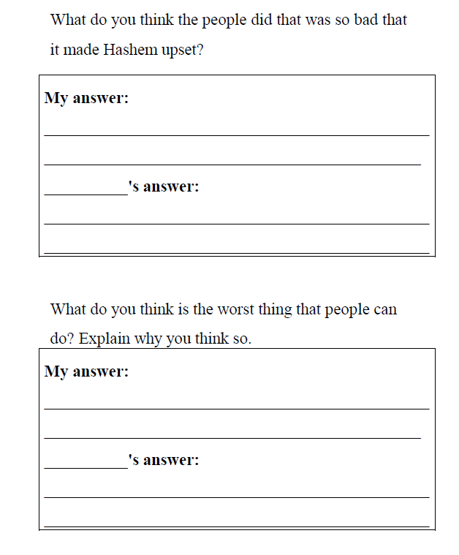

Technique #1: Example 2
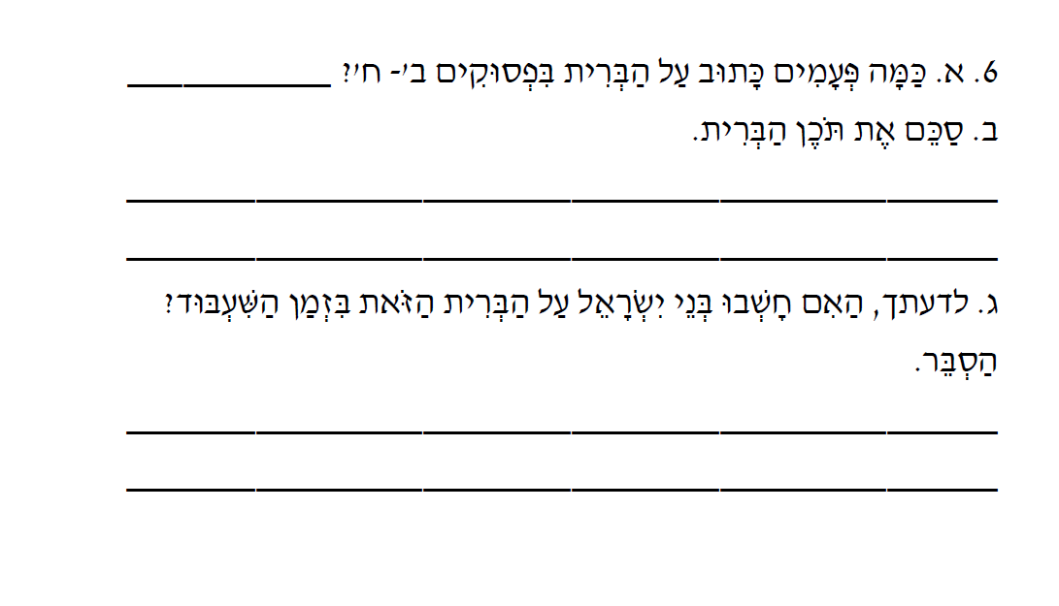
Technique #1: Example 3
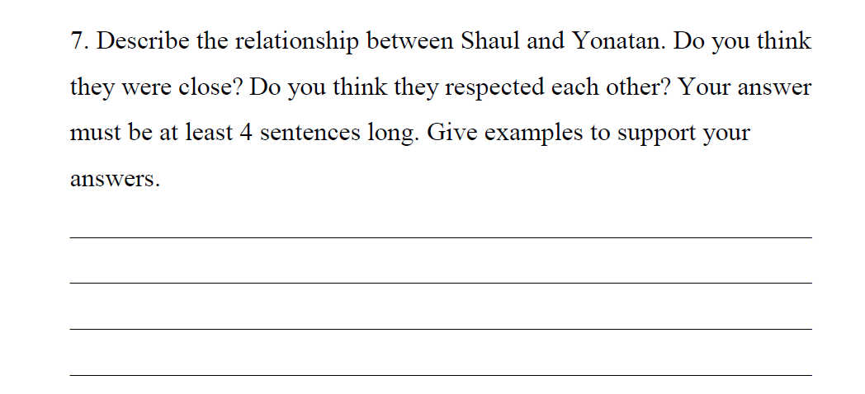

Technique #2: Example 1
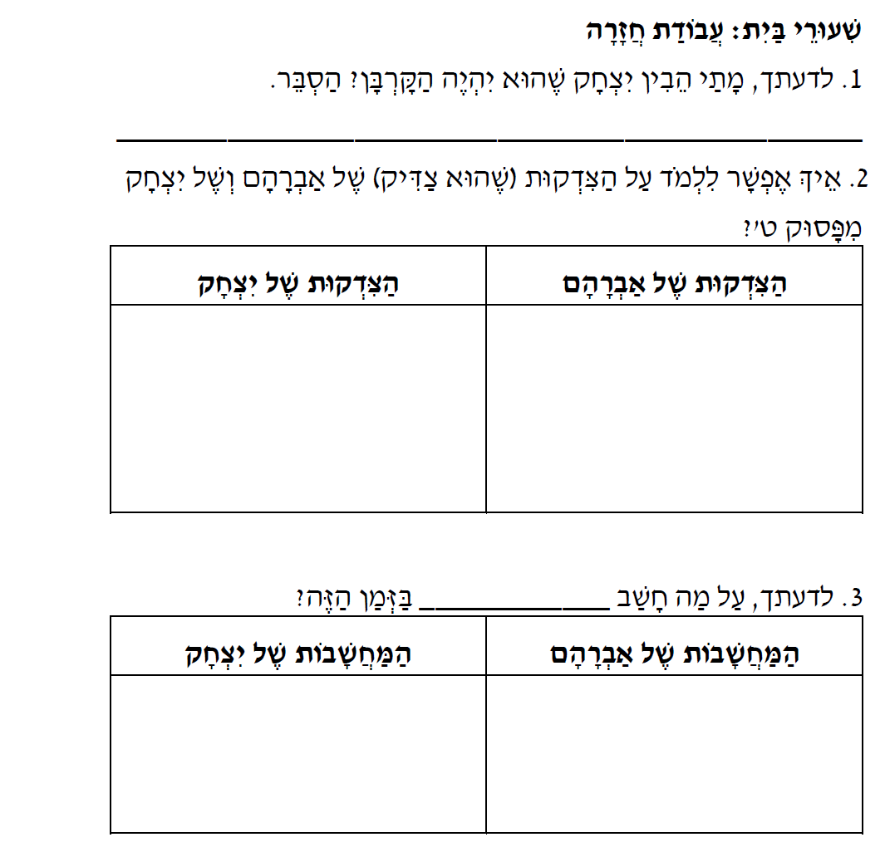

Technique #2: Example 2
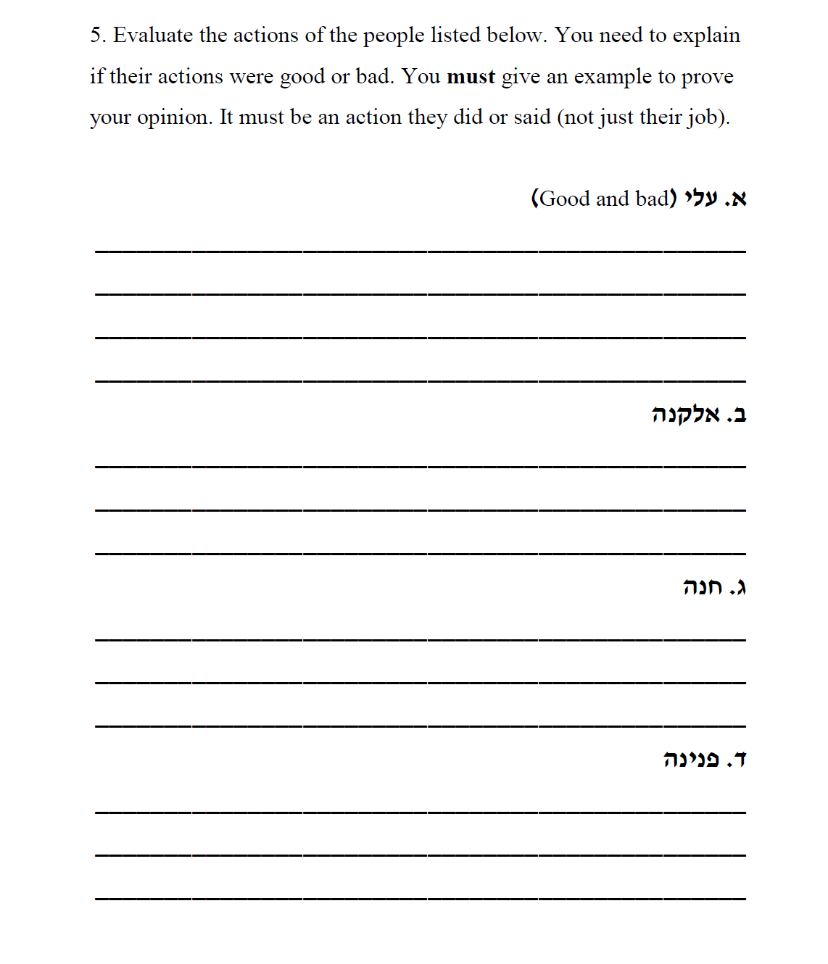

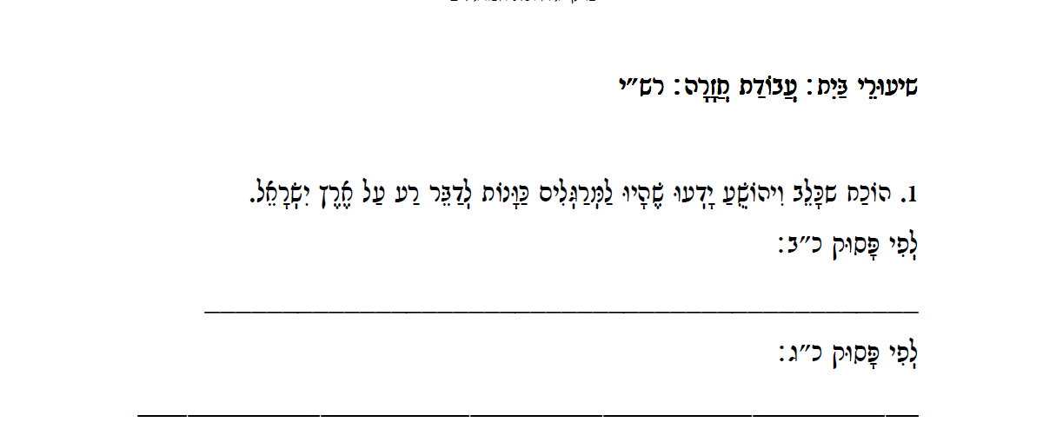
Technique #2: Example 3

Technique #3: Example 1
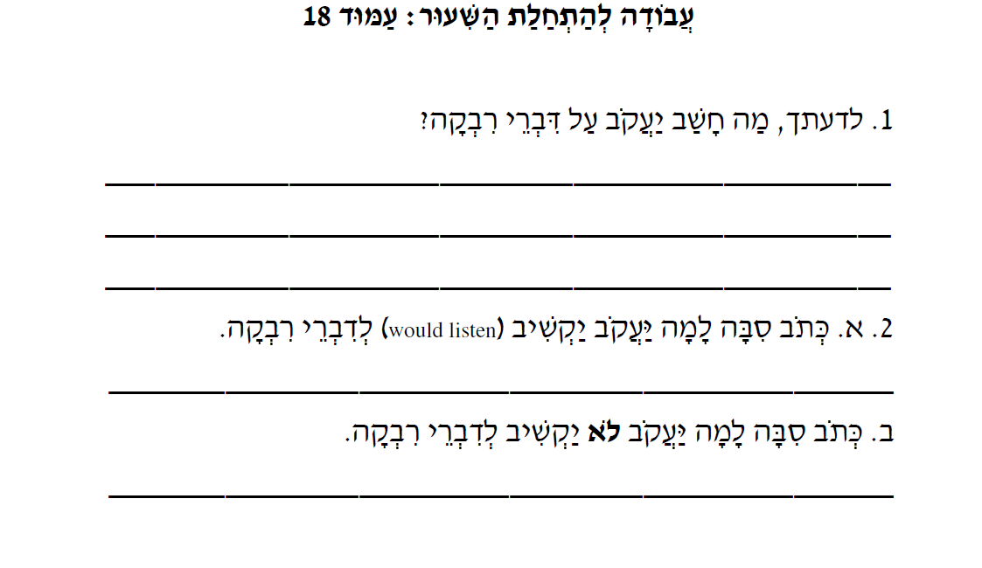

Technique #3: Example 2

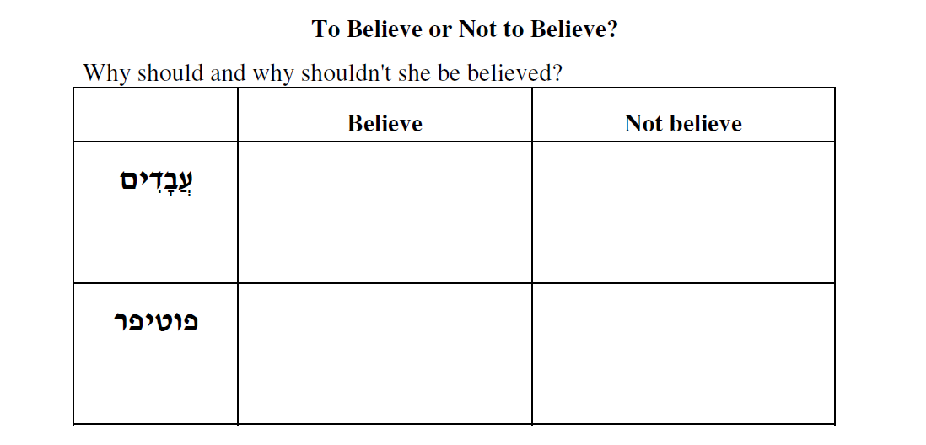

Technique #4: Example 1
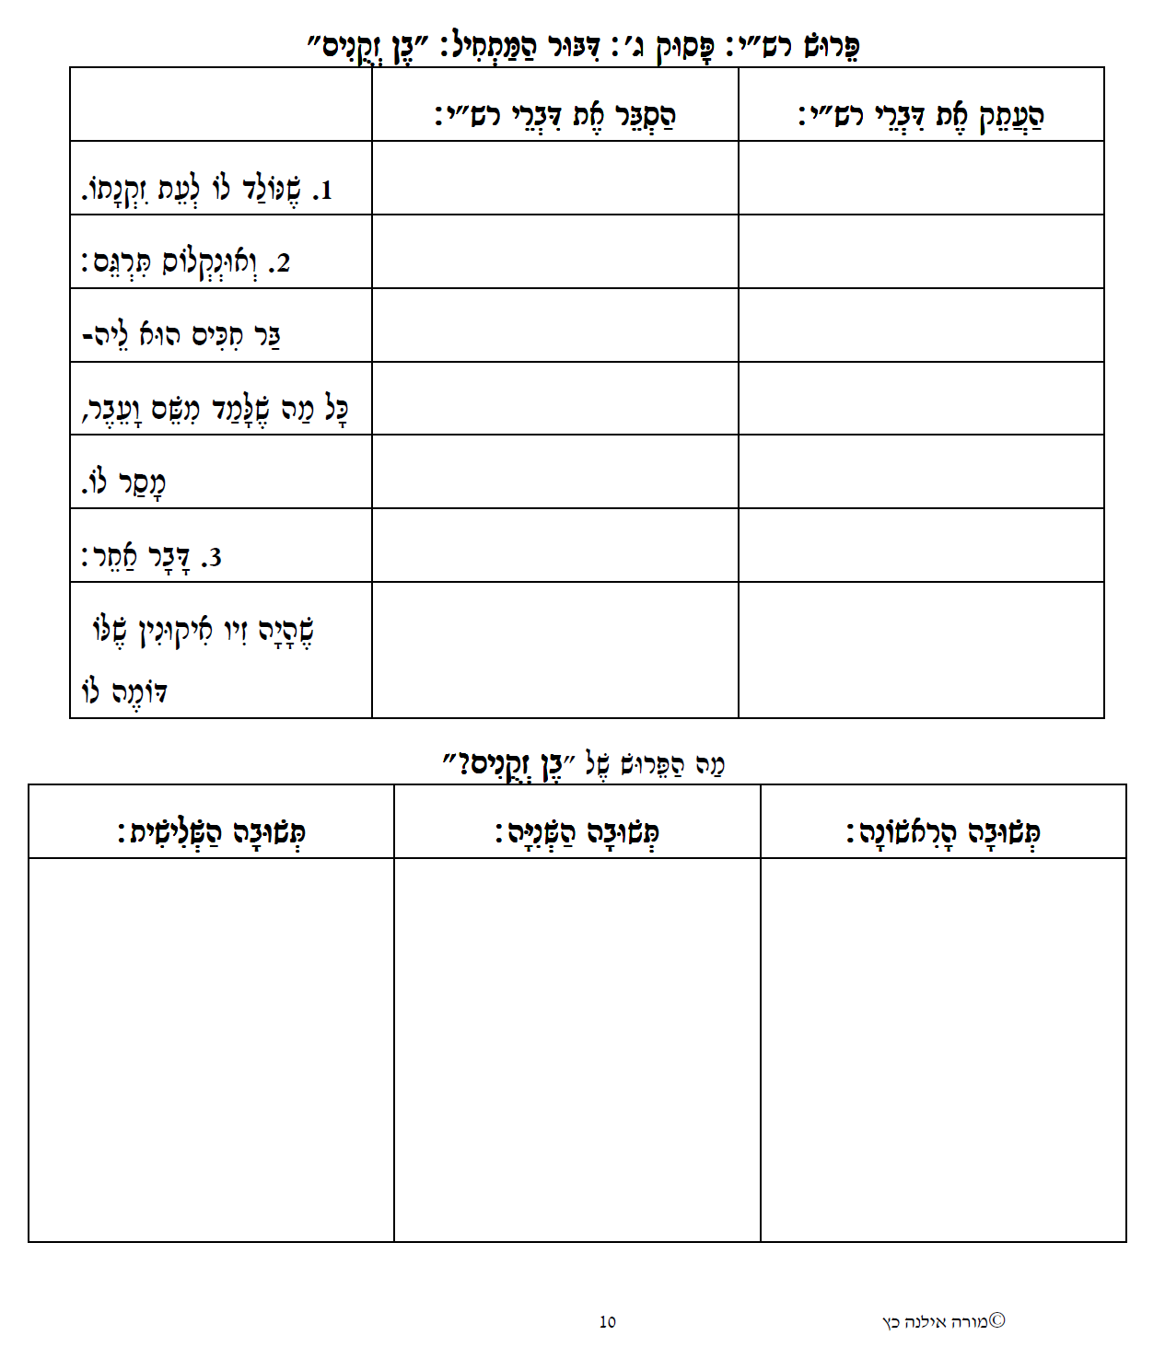

Technique #4: Example 2

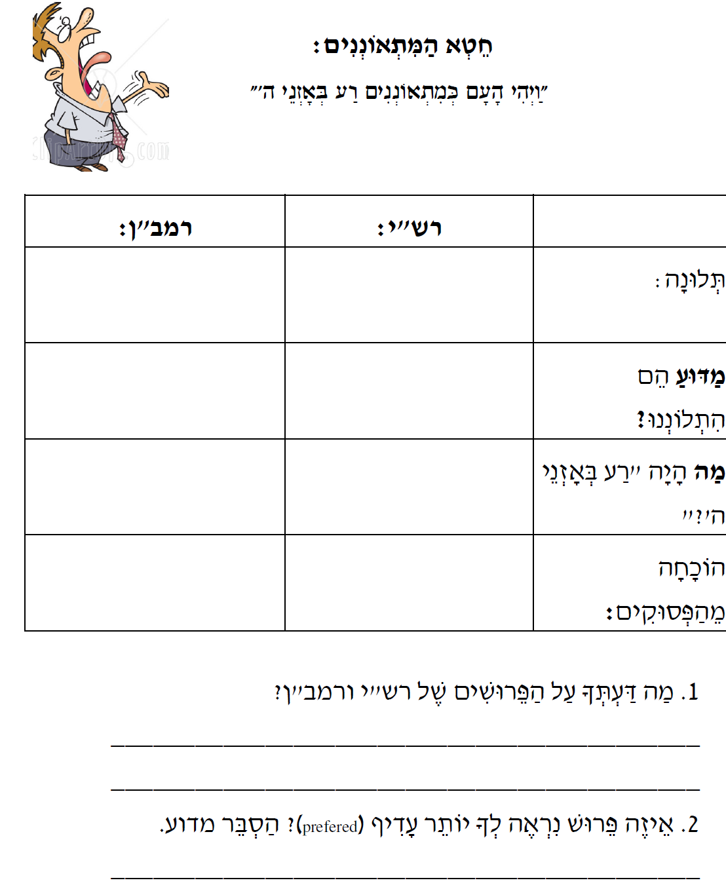

Technique #5: Example 1
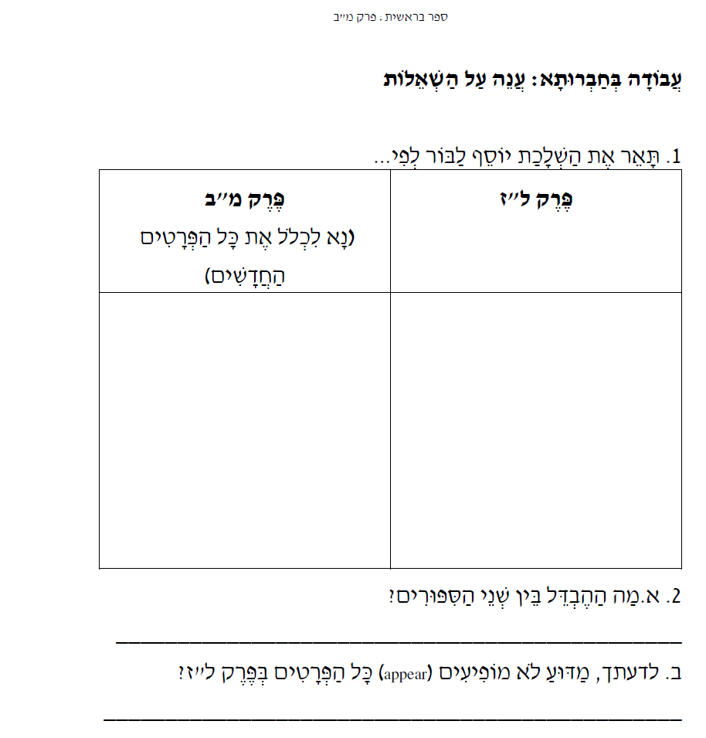

Technique #5: Example 2

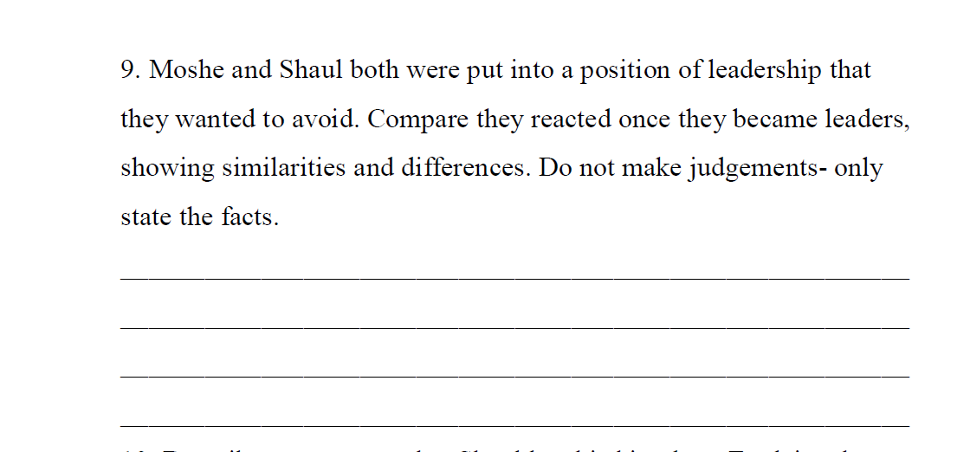
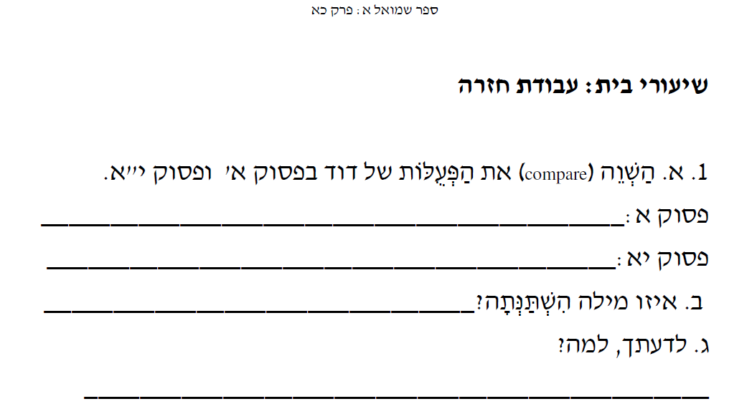
Technique #5: Example 3

